**25 CORE/BASIC PROGRAMS**

**25-01-22 9 progrms**

//1C prgrm to swap two variable

#include<stdio.h>

int main()

{

  int a,b,c;

a=1;

b=2;

printf("Value before swap:%d %d",a,b);

c=b;

b=a;

a=c;

printf("Value after swap:%d %d",a,b);

return 0;

}

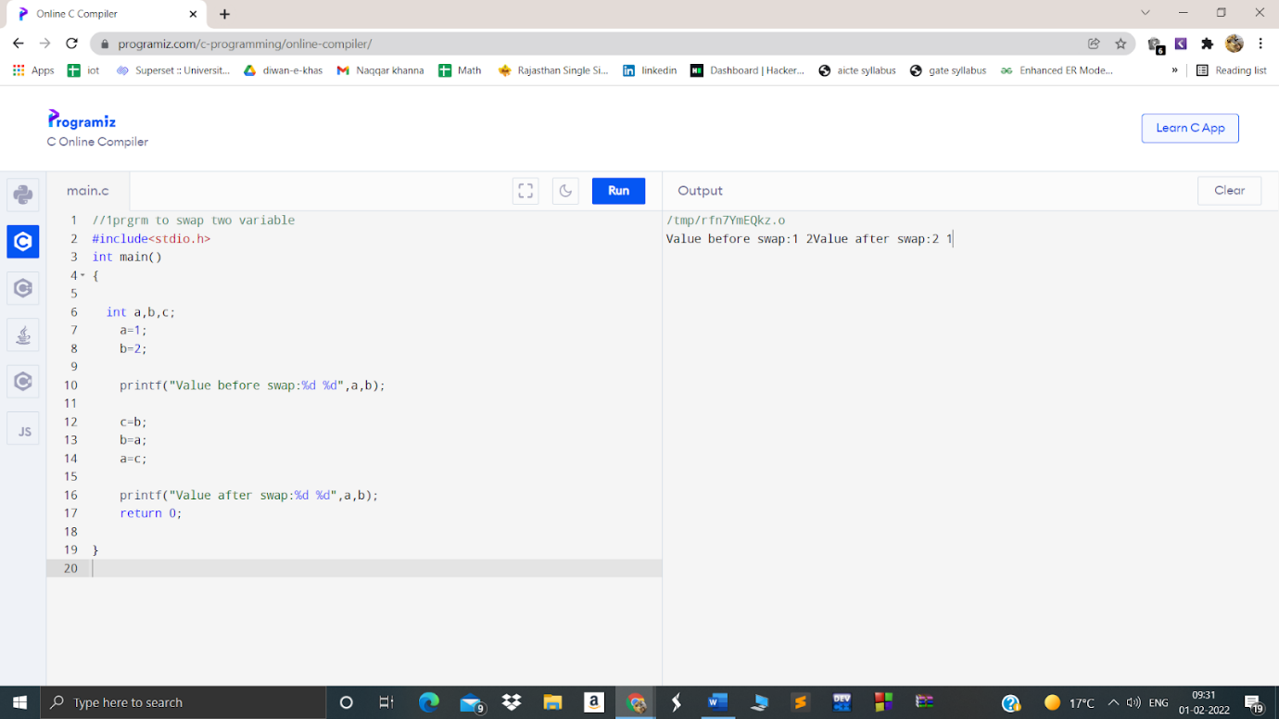

//2  prgm to swap two variable using 3rd variable

#include<stdio.h>

 int main()

{

int a=10, b=20;

printf("Before swap a=%d b=%d",a,b);

a=a+b;//a=30 (10+20)

b=a-b;//b=10 (30-20)

a=a-b;//a=20 (30-10)

printf("\nAfter swap a=%d b=%d",a,b);

return 0;

}

**Output:**

Before swapping.

a = 5, b = 10

After swapping.

a = 10, b = 5

.

//3 prgm to find area of circle

#include<stdio.h>

#include<conio.h>

#include<math.h>

int main()

{

float radius, area;

printf("\nEnter the radius of Circle : ");

scanf("%d",&radius);

printf("\nRadiusof Circle : %d",radius);

area = 3.14 * radius * radius;

printf("\nArea of Circle : %f", area);

return (0);

}

**Output:**

**Enter the radius of Circle : 2.0**

**Area of Circle : 6.14**

// 4 c prgram to finda area of Square

#include<stdio.h>

int main() {

int side, area;

printf("\nEnter the Length of Side : ");

scanf("%d", &side);

area = side * side;

printf("\nArea of Square : %d", area);

return (0);

}

Output:

Enter the Length of Side : 4

Area of Square : 16

//5 C prgm to finda area of rectangle

#include <stdio.h>

int main()

{

int width=5;

int height=10;

int area=width*height;

printf("Area of the rectangle=%d",area);

}

Output:Area of the rectangle=50

// 6c Prgm to calculate Simple interest using C++

#include<stdio.h>

int main()

{

float P , R , T , SI ;

P =34000; R =30; T = 5;

SI = (P*R*T)/100;

printf("\n\n Simple Interest is : %f", SI);

return (0);

}

Output:Simple Interest is : 51000.000000

//7C prgm To calculate Compount interest

#include<stdio.h>

#include<math.h>

void main()

{

float p,r,t,ci;

printf("Enter Principle, Rate and Time: ");

scanf("%f%f%f",&p,&r,&t);

ci=p*pow((1+r/100),t);

printf("Bank Loans Compound Interest = %f%",ci);

}

Output

Enter Principle, Rate and Time: 2000

2

3

Bank Loans Compound Interest = 2122.415771

//8To check if number is odd or even

#include <stdio.h>

int main() {

    int num;

    printf("Enter an integer: ");

    scanf("%d", &num);

    // true if num is perfectly divisible by 2

    if(num % 2 == 0)

        printf("%d is even.", num);

    else

        printf("%d is odd.", num);

    return 0;

}

Enter an integer: -7

-7 is odd.

//9    WAP to check meter to kilometer and if it is greater then 5 then print “Home delivery is not available “ else  print “Home delivery is available”

#include<stdio.h>

#include<conio.h>

int main()

{

int a;

float b;

scanf("%d",&a);

b = a/1000;

if(b>5)

printf("Home delivery is Available");

else

printf("not available");

getch();

}

Output:Home Delievery

**27/01/2022 7 programs**

10 WAP to Find Biggest number out of 3 numbers.

#include <stdio.h>

#include <conio.h>

void main()

{

int a, b, c;

clrscr();

printf("\nGreater Out of 3>> \n");

printf("Enter 3 Numbers >\n");

scanf("%d", &a);

scanf("%d", &b);

scanf("%d", &c);

printf("Greter is ");

if (a > c)

if (a > b)

printf("%d",a);

else

printf("%d",b);

else

if (c > b)

printf("%d",c);

else

printf("%d",b);

getch();

}

**OUTPUT:**

4 7 9

Largest Number:9

// 11 C prgrm to find greater among 4

#include <stdio.h>

#include <conio.h>

void main()

{

int a, b, c, d;

clrscr();

printf("\nGreater Out of 4>> \n");

printf("Enter 4 Numbers >\n");

scanf("%d", &a);

scanf("%d", &b);

scanf("%d", &c);

scanf("%d", &d);

printf("Greter is ");

if (a > d)

if (a > c)

if (a > b)

printf("%d",a);

else

printf("%d",b);

else

if (c > b)

printf("%d",c);

else

printf("%d",b);

else

if (d > c)

if (d > b)

printf("%d",d);

else

printf("%d",b);

else

if (c > b)

printf("%d",c);

else

printf("%d",b);

getch();

}

OUTPUT:

Enter four number:1 4 7 9

Largest Number:9

//12 C prgm to find Biggest out of 5 number

1. **int** main()
2. {
3. **int** a = 10, b = 50, c = 20, d = 25;
4. cout << "a=" << a << " b=" << b << " c=" << c << " d=" << d;
5. cout << "\n";
6. find_greatest(a, b, c, d);
7. a = 35, b = 50, c = 99, d = 2;
8. cout << "\n";
9. cout << "a=" << a << " b=" << b << " c=" << c << " d=" << d;
10. cout << "\n";
11. find_greatest(a, b, c, d);
13. **return** 0;
14. }

OUTPUT:

Enter four number:1 4 7 9 0

Largest Number:9

//13 C prgm to find greater among 6 variable

#include <stdio.h>

#include <conio.h>

void main()

{

int a, b, c, d, e, f;

clrscr();

printf("\nGreater Out of 6>> \n");

printf("Enter 6 Numbers >\n");

scanf("%d", &a);

scanf("%d", &b);

scanf("%d", &c);

scanf("%d", &d);

scanf("%d", &e);

scanf("%d", &f);

printf("Greter is ");

if (a > f)

if (a > e)

if (a > d)

if (a > c)

if (a > b)

printf("%d",a);

else

printf("%d",b);

else

if (c > b)

printf("%d",c);

else

printf("%d",b);

else

if (d > c)

if (d > b)

printf("%d",d);

else

printf("%d",b);

else

if (c > b)

printf("%d",c);

else

printf("%d",b);

else

if (e > d)

if (e > c)

if (e > b)

printf("%d",e);

else

printf("%d",b);

else

if (c > b)

printf("%d",c);

else

printf("%d",b);

else

if (d > c)

if (d > b)

printf("%d",d);

else

printf("%d",b);

else

if (c > b)

printf("%d",c);

else

printf("%d",b);

else

if (f > e)

if (f > d)

if (f > c)

if (f > b)

printf("%d",f);

else

printf("%d",b);

else

if (c > b)

printf("%d",c);

else

printf("%d",b);

else

if (d > c)

if (d > b)

printf("%d",d);

else

printf("%d",b);

else

if (c > b)

printf("%d",c);

else

printf("%d",b);

else

if (e > d)

if (e > c)

if (e > b)

printf("%d",e);

else

printf("%d",b);

else

if (c > b)

printf("%d",c);

else

printf("%d",b);

else

if (d > c)

if (d > b)

printf("%d",d);

else

printf("%d",b);

else

if (c > b)

printf("%d",c);

else

printf("%d",b);

getch();

}

OUTPUT:

Enter the number:11,2,4,5,9,0

Largest:11

//14 C prgm to find greater among 7 variable

#include <stdio.h>

#include <conio.h>

void main()

{

int a, b, c, d, e, f, g;

clrscr();

printf("\nGreater Out of 7>> \n");

printf("Enter 7 Numbers >\n");

scanf("%d", &a);

scanf("%d", &b);

scanf("%d", &c);

scanf("%d", &d);

scanf("%d", &e);

scanf("%d", &f);

scanf("%d", &g);

printf("Greter is ");

if (a > g)

if (a > f)

if (a > e)

if (a > d)

if (a > c)

if (a > b)

printf("%d",a);

else

printf("%d",b);

else

if (c > b)

printf("%d",c);

else

printf("%d",b);

else

if (d > c)

if (d > b)

printf("%d",d);

else

printf("%d",b);

else

if (c > b)

printf("%d",c);

else

printf("%d",b);

else

if (e > d)

if (e > c)

if (e > b)

printf("%d",e);

else

printf("%d",b);

else

if (c > b)

printf("%d",c);

else

printf("%d",b);

else

if (d > c)

if (d > b)

printf("%d",d);

else

printf("%d",b);

else

if (c > b)

printf("%d",c);

else

printf("%d",b);

else

if (f > e)

if (f > d)

if (f > c)

if (f > b)

printf("%d",f);

else

printf("%d",b);

else

if (c > b)

printf("%d",c);

else

printf("%d",b);

else

if (d > c)

if (d > b)

printf("%d",d);

else

printf("%d",b);

else

if (c > b)

printf("%d",c);

else

printf("%d",b);

else

if (e > d)

if (e > c)

if (e > b)

printf("%d",e);

else

printf("%d",b);

else

if (c > b)

printf("%d",c);

else

printf("%d",b);

else

if (d > c)

if (d > b)

printf("%d",d);

else

printf("%d",b);

else

if (c > b)

printf("%d",c);

else

printf("%d",b);

else

if (g > f)

if (g > e)

if (g > d)

if (g > c)

if (g > b)

printf("%d",g);

else

printf("%d",b);

else

if (c > b)

printf("%d",c);

else

printf("%d",b);

else

if (d > c)

if (d > b)

printf("%d",d);

else

printf("%d",b);

else

if (c > b)

printf("%d",c);

else

printf("%d",b);

else

if (e > d)

if (e > c)

if (e > b)

printf("%d",e);

else

printf("%d",b);

else

if (c > b)

printf("%d",c);

else

printf("%d",b);

else

if (d > c)

if (d > b)

printf("%d",d);

else

printf("%d",b);

else

if (c > b)

printf("%d",c);

else

printf("%d",b);

else

if (f > e)

if (f > d)

if (f > c)

if (f > b)

printf("%d",f);

else

printf("%d",b);

else

if (c > b)

printf("%d",c);

else

printf("%d",b);

else

if (d > c)

if (d > b)

printf("%d",d);

else

printf("%d",b);

else

if (c > b)

printf("%d",c);

else

printf("%d",b);

else

if (e > d)

if (e > c)

if (e > b)

printf("%d",e);

else

printf("%d",b);

else

if (c > b)

printf("%d",c);

else

printf("%d",b);

else

if (d > c)

if (d > b)

printf("%d",d);

else

printf("%d",b);

else

if (c > b)

printf("%d",c);

else

printf("%d",b);

getch();

}

Output:1,3,5,7,9,0,11

Largerst:11

//15     WAP to Find Biggest number out of 8 numbers.

#include <stdio.h>

#include <conio.h>

void main()

{

int a, b, c, d, e, f, g, h;

clrscr();

printf("\nGreater Out of 8>> \n");

printf("Enter 8 Numbers >\n");

scanf("%d", &a);

scanf("%d", &b);

scanf("%d", &c);

scanf("%d", &d);

scanf("%d", &e);

scanf("%d", &f);

scanf("%d", &g);

scanf("%d", &h);

printf("Greter is ");

if (a > h)

if (a > g)

if (a > f)

if (a > e)

if (a > d)

if (a > c)

if (a > b)

printf("%d",a);

else

printf("%d",b);

else

if (c > b)

printf("%d",c);

else

printf("%d",b);

else

if (d > c)

if (d > b)

printf("%d",d);

else

printf("%d",b);

else

if (c > b)

printf("%d",c);

else

printf("%d",b);

else

if (e > d)

if (e > c)

if (e > b)

printf("%d",e);

else

printf("%d",b);

else

if (c > b)

printf("%d",c);

else

printf("%d",b);

else

if (d > c)

if (d > b)

printf("%d",d);

else

printf("%d",b);

else

if (c > b)

printf("%d",c);

else

printf("%d",b);

else

if (f > e)

if (f > d)

if (f > c)

if (f > b)

printf("%d",f);

else

printf("%d",b);

else

if (c > b)

printf("%d",c);

else

printf("%d",b);

else

if (d > c)

if (d > b)

printf("%d",d);

else

printf("%d",b);

else

if (c > b)

printf("%d",c);

else

printf("%d",b);

else

if (e > d)

if (e > c)

if (e > b)

printf("%d",e);

else

printf("%d",b);

else

if (c > b)

printf("%d",c);

else

printf("%d",b);

else

if (d > c)

if (d > b)

printf("%d",d);

else

printf("%d",b);

else

if (c > b)

printf("%d",c);

else

printf("%d",b);

else

if (g > f)

if (g > e)

if (g > d)

if (g > c)

if (g > b)

printf("%d",g);

else

printf("%d",b);

else

if (c > b)

printf("%d",c);

else

printf("%d",b);

else

if (d > c)

if (d > b)

printf("%d",d);

else

printf("%d",b);

else

if (c > b)

printf("%d",c);

else

printf("%d",b);

else

if (e > d)

if (e > c)

if (e > b)

printf("%d",e);

else

printf("%d",b);

else

if (c > b)

printf("%d",c);

else

printf("%d",b);

else

if (d > c)

if (d > b)

printf("%d",d);

else

printf("%d",b);

else

if (c > b)

printf("%d",c);

else

printf("%d",b);

else

if (f > e)

if (f > d)

if (f > c)

if (f > b)

printf("%d",f);

else

printf("%d",b);

else

if (c > b)

printf("%d",c);

else

printf("%d",b);

else

if (d > c)

if (d > b)

printf("%d",d);

else

printf("%d",b);

else

if (c > b)

printf("%d",c);

else

printf("%d",b);

else

if (e > d)

if (e > c)

if (e > b)

printf("%d",e);

else

printf("%d",b);

else

if (c > b)

printf("%d",c);

else

printf("%d",b);

else

if (d > c)

if (d > b)

printf("%d",d);

else

printf("%d",b);

else

if (c > b)

printf("%d",c);

else

printf("%d",b);

else

if (h > g)

if (h > f)

if (h > e)

if (h > d)

if (h > c)

if (h > b)

printf("%d",h);

else

printf("%d",b);

else

if (c > b)

printf("%d",c);

else

printf("%d",b);

else

if (d > c)

if (d > b)

printf("%d",d);

else

printf("%d",b);

else

if (c > b)

printf("%d",c);

else

printf("%d",b);

else

if (e > d)

if (e > c)

if (e > b)

printf("%d",e);

else

printf("%d",b);

else

if (c > b)

printf("%d",c);

else

printf("%d",b);

else

if (d > c)

if (d > b)

printf("%d",d);

else

printf("%d",b);

else

if (c > b)

printf("%d",c);

else

printf("%d",b);

else

if (f > e)

if (f > d)

if (f > c)

if (f > b)

printf("%d",f);

else

printf("%d",b);

else

if (c > b)

printf("%d",c);

else

printf("%d",b);

else

if (d > c)

if (d > b)

printf("%d",d);

else

printf("%d",b);

else

if (c > b)

printf("%d",c);

else

printf("%d",b);

else

if (e > d)

if (e > c)

if (e > b)

printf("%d",e);

else

printf("%d",b);

else

if (c > b)

printf("%d",c);

else

printf("%d",b);

else

if (d > c)

if (d > b)

printf("%d",d);

else

printf("%d",b);

else

if (c > b)

printf("%d",c);

else

printf("%d",b);

else

if (g > f)

if (g > e)

if (g > d)

if (g > c)

if (g > b)

printf("%d",g);

else

printf("%d",b);

else

if (c > b)

printf("%d",c);

else

printf("%d",b);

else

if (d > c)

if (d > b)

printf("%d",d);

else

printf("%d",b);

else

if (c > b)

printf("%d",c);

else

printf("%d",b);

else

if (e > d)

if (e > c)

if (e > b)

printf("%d",e);

else

printf("%d",b);

else

if (c > b)

printf("%d",c);

else

printf("%d",b);

else

if (d > c)

if (d > b)

printf("%d",d);

else

printf("%d",b);

else

if (c > b)

printf("%d",c);

else

printf("%d",b);

else

if (f > e)

if (f > d)

if (f > c)

if (f > b)

printf("%d",f);

else

printf("%d",b);

else

if (c > b)

printf("%d",c);

else

printf("%d",b);

else

if (d > c)

if (d > b)

printf("%d",d);

else

printf("%d",b);

else

if (c > b)

printf("%d",c);

else

printf("%d",b);

else

if (e > d)

if (e > c)

if (e > b)

printf("%d",e);

else

printf("%d",b);

else

if (c > b)

printf("%d",c);

else

printf("%d",b);

else

if (d > c)

if (d > b)

printf("%d",d);

else

printf("%d",b);

else

if (c > b)

printf("%d",c);

else

printf("%d",b);

getch();

}

//16 c prgm to find greatest among 9

#include <stdio.h>

#include <conio.h>

void main()

{

int a, b, c, d, e, f, g, h, i, j;

clrscr();

printf("\nGreater Out of 9>> \n");

printf("Enter 9 Numbers >\n");

scanf("%d", &a);

scanf("%d", &b);

scanf("%d", &c);

scanf("%d", &d);

scanf("%d", &e);

scanf("%d", &f);

scanf("%d", &g);

scanf("%d", &h);

scanf("%d", &i);

printf("Greter is ");

if (a > i)

if (a > h)

if (a > g)

if (a > f)

if (a > e)

if (a > d)

if (a > c)

if (a > b)

printf("%d",a);

else

printf("%d",b);

else

if (c > b)

printf("%d",c);

else

printf("%d",b);

else

if (d > c)

if (d > b)

printf("%d",d);

else

printf("%d",b);

else

if (c > b)

printf("%d",c);

else

printf("%d",b);

else

if (e > d)

if (e > c)

if (e > b)

printf("%d",e);

else

printf("%d",b);

else

if (c > b)

printf("%d",c);

else

printf("%d",b);

else

if (d > c)

if (d > b)

printf("%d",d);

else

printf("%d",b);

else

if (c > b)

printf("%d",c);

else

printf("%d",b);

else

if (f > e)

if (f > d)

if (f > c)

if (f > b)

printf("%d",f);

else

printf("%d",b);

else

if (c > b)

printf("%d",c);

else

printf("%d",b);

else

if (d > c)

if (d > b)

printf("%d",d);

else

printf("%d",b);

else

if (c > b)

printf("%d",c);

else

printf("%d",b);

else

if (e > d)

if (e > c)

if (e > b)

printf("%d",e);

else

printf("%d",b);

else

if (c > b)

printf("%d",c);

else

printf("%d",b);

else

if (d > c)

if (d > b)

printf("%d",d);

else

printf("%d",b);

else

if (c > b)

printf("%d",c);

else

printf("%d",b);

else

if (g > f)

if (g > e)

if (g > d)

if (g > c)

if (g > b)

printf("%d",g);

else

printf("%d",b);

else

if (c > b)

printf("%d",c);

else

printf("%d",b);

else

if (d > c)

if (d > b)

printf("%d",d);

else

printf("%d",b);

else

if (c > b)

printf("%d",c);

else

printf("%d",b);

else

if (e > d)

if (e > c)

if (e > b)

printf("%d",e);

else

printf("%d",b);

else

if (c > b)

printf("%d",c);

else

printf("%d",b);

else

if (d > c)

if (d > b)

printf("%d",d);

else

printf("%d",b);

else

if (c > b)

printf("%d",c);

else

printf("%d",b);

else

if (f > e)

if (f > d)

if (f > c)

if (f > b)

printf("%d",f);

else

printf("%d",b);

else

if (c > b)

printf("%d",c);

else

printf("%d",b);

else

if (d > c)

if (d > b)

printf("%d",d);

else

printf("%d",b);

else

if (c > b)

printf("%d",c);

else

printf("%d",b);

else

if (e > d)

if (e > c)

if (e > b)

printf("%d",e);

else

printf("%d",b);

else

if (c > b)

printf("%d",c);

else

printf("%d",b);

else

if (d > c)

if (d > b)

printf("%d",d);

else

printf("%d",b);

else

if (c > b)

printf("%d",c);

else

printf("%d",b);

else

if (h > g)

if (h > f)

if (h > e)

if (h > d)

if (h > c)

if (h > b)

printf("%d",h);

else

printf("%d",b);

else

if (c > b)

printf("%d",c);

else

printf("%d",b);

else

if (d > c)

if (d > b)

printf("%d",d);

else

printf("%d",b);

else

if (c > b)

printf("%d",c);

else

printf("%d",b);

else

if (e > d)

if (e > c)

if (e > b)

printf("%d",e);

else

printf("%d",b);

else

if (c > b)

printf("%d",c);

else

printf("%d",b);

else

if (d > c)

if (d > b)

printf("%d",d);

else

printf("%d",b);

else

if (c > b)

printf("%d",c);

else

printf("%d",b);

else

if (f > e)

if (f > d)

if (f > c)

if (f > b)

printf("%d",f);

else

printf("%d",b);

else

if (c > b)

printf("%d",c);

else

printf("%d",b);

else

if (d > c)

if (d > b)

printf("%d",d);

else

printf("%d",b);

else

if (c > b)

printf("%d",c);

else

printf("%d",b);

else

if (e > d)

if (e > c)

if (e > b)

printf("%d",e);

else

printf("%d",b);

else

if (c > b)

printf("%d",c);

else

printf("%d",b);

else

if (d > c)

if (d > b)

printf("%d",d);

else

printf("%d",b);

else

if (c > b)

printf("%d",c);

else

printf("%d",b);

else

if (g > f)

if (g > e)

if (g > d)

if (g > c)

if (g > b)

printf("%d",g);

else

printf("%d",b);

else

if (c > b)

printf("%d",c);

else

printf("%d",b);

else

if (d > c)

if (d > b)

printf("%d",d);

else

printf("%d",b);

else

if (c > b)

printf("%d",c);

else

printf("%d",b);

else

if (e > d)

if (e > c)

if (e > b)

printf("%d",e);

else

printf("%d",b);

else

if (c > b)

printf("%d",c);

else

printf("%d",b);

else

if (d > c)

if (d > b)

printf("%d",d);

else

printf("%d",b);

else

if (c > b)

printf("%d",c);

else

printf("%d",b);

else

if (f > e)

if (f > d)

if (f > c)

if (f > b)

printf("%d",f);

else

printf("%d",b);

else

if (c > b)

printf("%d",c);

else

printf("%d",b);

else

if (d > c)

if (d > b)

printf("%d",d);

else

printf("%d",b);

else

if (c > b)

printf("%d",c);

else

printf("%d",b);

else

if (e > d)

if (e > c)

if (e > b)

printf("%d",e);

else

printf("%d",b);

else

if (c > b)

printf("%d",c);

else

printf("%d",b);

else

if (d > c)

if (d > b)

printf("%d",d);

else

printf("%d",b);

else

if (c > b)

printf("%d",c);

else

printf("%d",b);

else

if (i > h)

if (i > g)

if (i > f)

if (i > e)

if (i > d)

if (i > c)

if (i > b)

printf("%d",i);

else

printf("%d",b);

else

if (c > b)

printf("%d",c);

else

printf("%d",b);

else

if (d > c)

if (d > b)

printf("%d",d);

else

printf("%d",b);

else

if (c > b)

printf("%d",c);

else

printf("%d",b);

else

if (e > d)

if (e > c)

if (e > b)

printf("%d",e);

else

printf("%d",b);

else

if (c > b)

printf("%d",c);

else

printf("%d",b);

else

if (d > c)

if (d > b)

printf("%d",d);

else

printf("%d",b);

else

if (c > b)

printf("%d",c);

else

printf("%d",b);

else

if (f > e)

if (f > d)

if (f > c)

if (f > b)

printf("%d",f);

else

printf("%d",b);

else

if (c > b)

printf("%d",c);

else

printf("%d",b);

else

if (d > c)

if (d > b)

printf("%d",d);

else

printf("%d",b);

else

if (c > b)

printf("%d",c);

else

printf("%d",b);

else

if (e > d)

if (e > c)

if (e > b)

printf("%d",e);

else

printf("%d",b);

else

if (c > b)

printf("%d",c);

else

printf("%d",b);

else

if (d > c)

if (d > b)

printf("%d",d);

else

printf("%d",b);

else

if (c > b)

printf("%d",c);

else

printf("%d",b);

else

if (g > f)

if (g > e)

if (g > d)

if (g > c)

if (g > b)

printf("%d",g);

else

printf("%d",b);

else

if (c > b)

printf("%d",c);

else

printf("%d",b);

else

if (d > c)

if (d > b)

printf("%d",d);

else

printf("%d",b);

else

if (c > b)

printf("%d",c);

else

printf("%d",b);

else

if (e > d)

if (e > c)

if (e > b)

printf("%d",e);

else

printf("%d",b);

else

if (c > b)

printf("%d",c);

else

printf("%d",b);

else

if (d > c)

if (d > b)

printf("%d",d);

else

printf("%d",b);

else

if (c > b)

printf("%d",c);

else

printf("%d",b);

else

if (f > e)

if (f > d)

if (f > c)

if (f > b)

printf("%d",f);

else

printf("%d",b);

else

if (c > b)

printf("%d",c);

else

printf("%d",b);

else

if (d > c)

if (d > b)

printf("%d",d);

else

printf("%d",b);

else

if (c > b)

printf("%d",c);

else

printf("%d",b);

else

if (e > d)

if (e > c)

if (e > b)

printf("%d",e);

else

printf("%d",b);

else

if (c > b)

printf("%d",c);

else

printf("%d",b);

else

if (d > c)

if (d > b)

printf("%d",d);

else

printf("%d",b);

else

if (c > b)

printf("%d",c);

else

printf("%d",b);

else

if (h > g)

if (h > f)

if (h > e)

if (h > d)

if (h > c)

if (h > b)

printf("%d",h);

else

printf("%d",b);

else

if (c > b)

printf("%d",c);

else

printf("%d",b);

else

if (d > c)

if (d > b)

printf("%d",d);

else

printf("%d",b);

else

if (c > b)

printf("%d",c);

else

printf("%d",b);

else

if (e > d)

if (e > c)

if (e > b)

printf("%d",e);

else

printf("%d",b);

else

if (c > b)

printf("%d",c);

else

printf("%d",b);

else

if (d > c)

if (d > b)

printf("%d",d);

else

printf("%d",b);

else

if (c > b)

printf("%d",c);

else

printf("%d",b);

else

if (f > e)

if (f > d)

if (f > c)

if (f > b)

printf("%d",f);

else

printf("%d",b);

else

if (c > b)

printf("%d",c);

else

printf("%d",b);

else

if (d > c)

if (d > b)

printf("%d",d);

else

printf("%d",b);

else

if (c > b)

printf("%d",c);

else

printf("%d",b);

else

if (e > d)

if (e > c)

if (e > b)

printf("%d",e);

else

printf("%d",b);

else

if (c > b)

printf("%d",c);

else

printf("%d",b);

else

if (d > c)

if (d > b)

printf("%d",d);

else

printf("%d",b);

else

if (c > b)

printf("%d",c);

else

printf("%d",b);

else

if (g > f)

if (g > e)

if (g > d)

if (g > c)

if (g > b)

printf("%d",g);

else

printf("%d",b);

else

if (c > b)

printf("%d",c);

else

printf("%d",b);

else

if (d > c)

if (d > b)

printf("%d",d);

else

printf("%d",b);

else

if (c > b)

printf("%d",c);

else

printf("%d",b);

else

if (e > d)

if (e > c)

if (e > b)

printf("%d",e);

else

printf("%d",b);

else

if (c > b)

printf("%d",c);

else

printf("%d",b);

else

if (d > c)

if (d > b)

printf("%d",d);

else

printf("%d",b);

else

if (c > b)

printf("%d",c);

else

printf("%d",b);

else

if (f > e)

if (f > d)

if (f > c)

if (f > b)

printf("%d",f);

else

printf("%d",b);

else

if (c > b)

printf("%d",c);

else

printf("%d",b);

else

if (d > c)

if (d > b)

printf("%d",d);

else

printf("%d",b);

else

if (c > b)

printf("%d",c);

else

printf("%d",b);

else

if (e > d)

if (e > c)

if (e > b)

printf("%d",e);

else

printf("%d",b);

else

if (c > b)

printf("%d",c);

else

printf("%d",b);

else

if (d > c)

if (d > b)

printf("%d",d);

else

printf("%d",b);

else

if (c > b)

printf("%d",c);

else

printf("%d",b);

getch();

}

OUTPUT:0,2,4,6,8,10,12,14,18

Largest:14

//17 Cprgm to find greatest among 10

#include <stdio.h>

#include <conio.h>

void main()

{

int a, b, c, d, e, f, g, h, i, j;

clrscr();

printf("\nGreater Out of 10>> \n");

printf("Enter 10 Numbers >\n");

scanf("%d", &a);

scanf("%d", &b);

scanf("%d", &c);

scanf("%d", &d);

scanf("%d", &e);

scanf("%d", &f);

scanf("%d", &g);

scanf("%d", &h);

scanf("%d", &i);

scanf("%d", &j);

printf("Greter is ");

if (a > j)

if (a > i)

if (a > h)

if (a > g)

if (a > f)

if (a > e)

if (a > d)

if (a > c)

if (a > b)

printf("%d",a);

else

printf("%d",b);

else

if (c > b)

printf("%d",c);

else

printf("%d",b);

else

if (d > c)

if (d > b)

printf("%d",d);

else

printf("%d",b);

else

if (c > b)

printf("%d",c);

else

printf("%d",b);

else

if (e > d)

if (e > c)

if (e > b)

printf("%d",e);

else

printf("%d",b);

else

if (c > b)

printf("%d",c);

else

printf("%d",b);

else

if (d > c)

if (d > b)

printf("%d",d);

else

printf("%d",b);

else

if (c > b)

printf("%d",c);

else

printf("%d",b);

else

if (f > e)

if (f > d)

if (f > c)

if (f > b)

printf("%d",f);

else

printf("%d",b);

else

if (c > b)

printf("%d",c);

else

printf("%d",b);

else

if (d > c)

if (d > b)

printf("%d",d);

else

printf("%d",b);

else

if (c > b)

printf("%d",c);

else

printf("%d",b);

else

if (e > d)

if (e > c)

if (e > b)

printf("%d",e);

else

printf("%d",b);

else

if (c > b)

printf("%d",c);

else

printf("%d",b);

else

if (d > c)

if (d > b)

printf("%d",d);

else

printf("%d",b);

else

if (c > b)

printf("%d",c);

else

printf("%d",b);

else

if (g > f)

if (g > e)

if (g > d)

if (g > c)

if (g > b)

printf("%d",g);

else

printf("%d",b);

else

if (c > b)

printf("%d",c);

else

printf("%d",b);

else

if (d > c)

if (d > b)

printf("%d",d);

else

printf("%d",b);

else

if (c > b)

printf("%d",c);

else

printf("%d",b);

else

if (e > d)

if (e > c)

if (e > b)

printf("%d",e);

else

printf("%d",b);

else

if (c > b)

printf("%d",c);

else

printf("%d",b);

else

if (d > c)

if (d > b)

printf("%d",d);

else

printf("%d",b);

else

if (c > b)

printf("%d",c);

else

printf("%d",b);

else

if (f > e)

if (f > d)

if (f > c)

if (f > b)

printf("%d",f);

else

printf("%d",b);

else

if (c > b)

printf("%d",c);

else

printf("%d",b);

else

if (d > c)

if (d > b)

printf("%d",d);

else

printf("%d",b);

else

if (c > b)

printf("%d",c);

else

printf("%d",b);

else

if (e > d)

if (e > c)

if (e > b)

printf("%d",e);

else

printf("%d",b);

else

if (c > b)

printf("%d",c);

else

printf("%d",b);

else

if (d > c)

if (d > b)

printf("%d",d);

else

printf("%d",b);

else

if (c > b)

printf("%d",c);

else

printf("%d",b);

else

if (h > g)

if (h > f)

if (h > e)

if (h > d)

if (h > c)

if (h > b)

printf("%d",h);

else

printf("%d",b);

else

if (c > b)

printf("%d",c);

else

printf("%d",b);

else

if (d > c)

if (d > b)

printf("%d",d);

else

printf("%d",b);

else

if (c > b)

printf("%d",c);

else

printf("%d",b);

else

if (e > d)

if (e > c)

if (e > b)

printf("%d",e);

else

printf("%d",b);

else

if (c > b)

printf("%d",c);

else

printf("%d",b);

else

if (d > c)

if (d > b)

printf("%d",d);

else

printf("%d",b);

else

if (c > b)

printf("%d",c);

else

printf("%d",b);

else

if (f > e)

if (f > d)

if (f > c)

if (f > b)

printf("%d",f);

else

printf("%d",b);

else

if (c > b)

printf("%d",c);

else

printf("%d",b);

else

if (d > c)

if (d > b)

printf("%d",d);

else

printf("%d",b);

else

if (c > b)

printf("%d",c);

else

printf("%d",b);

else

if (e > d)

if (e > c)

if (e > b)

printf("%d",e);

else

printf("%d",b);

else

if (c > b)

printf("%d",c);

else

printf("%d",b);

else

if (d > c)

if (d > b)

printf("%d",d);

else

printf("%d",b);

else

if (c > b)

printf("%d",c);

else

printf("%d",b);

else

if (g > f)

if (g > e)

if (g > d)

if (g > c)

if (g > b)

printf("%d",g);

else

printf("%d",b);

else

if (c > b)

printf("%d",c);

else

printf("%d",b);

else

if (d > c)

if (d > b)

printf("%d",d);

else

printf("%d",b);

else

if (c > b)

printf("%d",c);

else

printf("%d",b);

else

if (e > d)

if (e > c)

if (e > b)

printf("%d",e);

else

printf("%d",b);

else

if (c > b)

printf("%d",c);

else

printf("%d",b);

else

if (d > c)

if (d > b)

printf("%d",d);

else

printf("%d",b);

else

if (c > b)

printf("%d",c);

else

printf("%d",b);

else

if (f > e)

if (f > d)

if (f > c)

if (f > b)

printf("%d",f);

else

printf("%d",b);

else

if (c > b)

printf("%d",c);

else

printf("%d",b);

else

if (d > c)

if (d > b)

printf("%d",d);

else

printf("%d",b);

else

if (c > b)

printf("%d",c);

else

printf("%d",b);

else

if (e > d)

if (e > c)

if (e > b)

printf("%d",e);

else

printf("%d",b);

else

if (c > b)

printf("%d",c);

else

printf("%d",b);

else

if (d > c)

if (d > b)

printf("%d",d);

else

printf("%d",b);

else

if (c > b)

printf("%d",c);

else

printf("%d",b);

else

if (i > h)

if (i > g)

if (i > f)

if (i > e)

if (i > d)

if (i > c)

if (i > b)

printf("%d",i);

else

printf("%d",b);

else

if (c > b)

printf("%d",c);

else

printf("%d",b);

else

if (d > c)

if (d > b)

printf("%d",d);

else

printf("%d",b);

else

if (c > b)

printf("%d",c);

else

printf("%d",b);

else

if (e > d)

if (e > c)

if (e > b)

printf("%d",e);

else

printf("%d",b);

else

if (c > b)

printf("%d",c);

else

printf("%d",b);

else

if (d > c)

if (d > b)

printf("%d",d);

else

printf("%d",b);

else

if (c > b)

printf("%d",c);

else

printf("%d",b);

else

if (f > e)

if (f > d)

if (f > c)

if (f > b)

printf("%d",f);

else

printf("%d",b);

else

if (c > b)

printf("%d",c);

else

printf("%d",b);

else

if (d > c)

if (d > b)

printf("%d",d);

else

printf("%d",b);

else

if (c > b)

printf("%d",c);

else

printf("%d",b);

else

if (e > d)

if (e > c)

if (e > b)

printf("%d",e);

else

printf("%d",b);

else

if (c > b)

printf("%d",c);

else

printf("%d",b);

else

if (d > c)

if (d > b)

printf("%d",d);

else

printf("%d",b);

else

if (c > b)

printf("%d",c);

else

printf("%d",b);

else

if (g > f)

if (g > e)

if (g > d)

if (g > c)

if (g > b)

printf("%d",g);

else

printf("%d",b);

else

if (c > b)

printf("%d",c);

else

printf("%d",b);

else

if (d > c)

if (d > b)

printf("%d",d);

else

printf("%d",b);

else

if (c > b)

printf("%d",c);

else

printf("%d",b);

else

if (e > d)

if (e > c)

if (e > b)

printf("%d",e);

else

printf("%d",b);

else

if (c > b)

printf("%d",c);

else

printf("%d",b);

else

if (d > c)

if (d > b)

printf("%d",d);

else

printf("%d",b);

else

if (c > b)

printf("%d",c);

else

printf("%d",b);

else

if (f > e)

if (f > d)

if (f > c)

if (f > b)

printf("%d",f);

else

printf("%d",b);

else

if (c > b)

printf("%d",c);

else

printf("%d",b);

else

if (d > c)

if (d > b)

printf("%d",d);

else

printf("%d",b);

else

if (c > b)

printf("%d",c);

else

printf("%d",b);

else

if (e > d)

if (e > c)

if (e > b)

printf("%d",e);

else

printf("%d",b);

else

if (c > b)

printf("%d",c);

else

printf("%d",b);

else

if (d > c)

if (d > b)

printf("%d",d);

else

printf("%d",b);

else

if (c > b)

printf("%d",c);

else

printf("%d",b);

else

if (h > g)

if (h > f)

if (h > e)

if (h > d)

if (h > c)

if (h > b)

printf("%d",h);

else

printf("%d",b);

else

if (c > b)

printf("%d",c);

else

printf("%d",b);

else

if (d > c)

if (d > b)

printf("%d",d);

else

printf("%d",b);

else

if (c > b)

printf("%d",c);

else

printf("%d",b);

else

if (e > d)

if (e > c)

if (e > b)

printf("%d",e);

else

printf("%d",b);

else

if (c > b)

printf("%d",c);

else

printf("%d",b);

else

if (d > c)

if (d > b)

printf("%d",d);

else

printf("%d",b);

else

if (c > b)

printf("%d",c);

else

printf("%d",b);

else

if (f > e)

if (f > d)

if (f > c)

if (f > b)

printf("%d",f);

else

printf("%d",b);

else

if (c > b)

printf("%d",c);

else

printf("%d",b);

else

if (d > c)

if (d > b)

printf("%d",d);

else

printf("%d",b);

else

if (c > b)

printf("%d",c);

else

printf("%d",b);

else

if (e > d)

if (e > c)

if (e > b)

printf("%d",e);

else

printf("%d",b);

else

if (c > b)

printf("%d",c);

else

printf("%d",b);

else

if (d > c)

if (d > b)

printf("%d",d);

else

printf("%d",b);

else

if (c > b)

printf("%d",c);

else

printf("%d",b);

else

if (g > f)

if (g > e)

if (g > d)

if (g > c)

if (g > b)

printf("%d",g);

else

printf("%d",b);

else

if (c > b)

printf("%d",c);

else

printf("%d",b);

else

if (d > c)

if (d > b)

printf("%d",d);

else

printf("%d",b);

else

if (c > b)

printf("%d",c);

else

printf("%d",b);

else

if (e > d)

if (e > c)

if (e > b)

printf("%d",e);

else

printf("%d",b);

else

if (c > b)

printf("%d",c);

else

printf("%d",b);

else

if (d > c)

if (d > b)

printf("%d",d);

else

printf("%d",b);

else

if (c > b)

printf("%d",c);

else

printf("%d",b);

else

if (f > e)

if (f > d)

if (f > c)

if (f > b)

printf("%d",f);

else

printf("%d",b);

else

if (c > b)

printf("%d",c);

else

printf("%d",b);

else

if (d > c)

if (d > b)

printf("%d",d);

else

printf("%d",b);

else

if (c > b)

printf("%d",c);

else

printf("%d",b);

else

if (e > d)

if (e > c)

if (e > b)

printf("%d",e);

else

printf("%d",b);

else

if (c > b)

printf("%d",c);

else

printf("%d",b);

else

if (d > c)

if (d > b)

printf("%d",d);

else

printf("%d",b);

else

if (c > b)

printf("%d",c);

else

printf("%d",b);

else

if (j > i)

if (j > h)

if (j > g)

if (j > f)

if (j > e)

if (j > d)

if (j > c)

if (j > b)

printf("%d",j);

else

printf("%d",b);

else

if (c > b)

printf("%d",c);

else

printf("%d",b);

else

if (d > c)

if (d > b)

printf("%d",d);

else

printf("%d",b);

else

if (c > b)

printf("%d",c);

else

printf("%d",b);

else

if (e > d)

if (e > c)

if (e > b)

printf("%d",e);

else

printf("%d",b);

else

if (c > b)

printf("%d",c);

else

printf("%d",b);

else

if (d > c)

if (d > b)

printf("%d",d);

else

printf("%d",b);

else

if (c > b)

printf("%d",c);

else

printf("%d",b);

else

if (f > e)

if (f > d)

if (f > c)

if (f > b)

printf("%d",f);

else

printf("%d",b);

else

if (c > b)

printf("%d",c);

else

printf("%d",b);

else

if (d > c)

if (d > b)

printf("%d",d);

else

printf("%d",b);

else

if (c > b)

printf("%d",c);

else

printf("%d",b);

else

if (e > d)

if (e > c)

if (e > b)

printf("%d",e);

else

printf("%d",b);

else

if (c > b)

printf("%d",c);

else

printf("%d",b);

else

if (d > c)

if (d > b)

printf("%d",d);

else

printf("%d",b);

else

if (c > b)

printf("%d",c);

else

printf("%d",b);

else

if (g > f)

if (g > e)

if (g > d)

if (g > c)

if (g > b)

printf("%d",g);

else

printf("%d",b);

else

if (c > b)

printf("%d",c);

else

printf("%d",b);

else

if (d > c)

if (d > b)

printf("%d",d);

else

printf("%d",b);

else

if (c > b)

printf("%d",c);

else

printf("%d",b);

else

if (e > d)

if (e > c)

if (e > b)

printf("%d",e);

else

printf("%d",b);

else

if (c > b)

printf("%d",c);

else

printf("%d",b);

else

if (d > c)

if (d > b)

printf("%d",d);

else

printf("%d",b);

else

if (c > b)

printf("%d",c);

else

printf("%d",b);

else

if (f > e)

if (f > d)

if (f > c)

if (f > b)

printf("%d",f);

else

printf("%d",b);

else

if (c > b)

printf("%d",c);

else

printf("%d",b);

else

if (d > c)

if (d > b)

printf("%d",d);

else

printf("%d",b);

else

if (c > b)

printf("%d",c);

else

printf("%d",b);

else

if (e > d)

if (e > c)

if (e > b)

printf("%d",e);

else

printf("%d",b);

else

if (c > b)

printf("%d",c);

else

printf("%d",b);

else

if (d > c)

if (d > b)

printf("%d",d);

else

printf("%d",b);

else

if (c > b)

printf("%d",c);

else

printf("%d",b);

else

if (h > g)

if (h > f)

if (h > e)

if (h > d)

if (h > c)

if (h > b)

printf("%d",h);

else

printf("%d",b);

else

if (c > b)

printf("%d",c);

else

printf("%d",b);

else

if (d > c)

if (d > b)

printf("%d",d);

else

printf("%d",b);

else

if (c > b)

printf("%d",c);

else

printf("%d",b);

else

if (e > d)

if (e > c)

if (e > b)

printf("%d",e);

else

printf("%d",b);

else

if (c > b)

printf("%d",c);

else

printf("%d",b);

else

if (d > c)

if (d > b)

printf("%d",d);

else

printf("%d",b);

else

if (c > b)

printf("%d",c);

else

printf("%d",b);

else

if (f > e)

if (f > d)

if (f > c)

if (f > b)

printf("%d",f);

else

printf("%d",b);

else

if (c > b)

printf("%d",c);

else

printf("%d",b);

else

if (d > c)

if (d > b)

printf("%d",d);

else

printf("%d",b);

else

if (c > b)

printf("%d",c);

else

printf("%d",b);

else

if (e > d)

if (e > c)

if (e > b)

printf("%d",e);

else

printf("%d",b);

else

if (c > b)

printf("%d",c);

else

printf("%d",b);

else

if (d > c)

if (d > b)

printf("%d",d);

else

printf("%d",b);

else

if (c > b)

printf("%d",c);

else

printf("%d",b);

else

if (g > f)

if (g > e)

if (g > d)

if (g > c)

if (g > b)

printf("%d",g);

else

printf("%d",b);

else

if (c > b)

printf("%d",c);

else

printf("%d",b);

else

if (d > c)

if (d > b)

printf("%d",d);

else

printf("%d",b);

else

if (c > b)

printf("%d",c);

else

printf("%d",b);

else

if (e > d)

if (e > c)

if (e > b)

printf("%d",e);

else

printf("%d",b);

else

if (c > b)

printf("%d",c);

else

printf("%d",b);

else

if (d > c)

if (d > b)

printf("%d",d);

else

printf("%d",b);

else

if (c > b)

printf("%d",c);

else

printf("%d",b);

else

if (f > e)

if (f > d)

if (f > c)

if (f > b)

printf("%d",f);

else

printf("%d",b);

else

if (c > b)

printf("%d",c);

else

printf("%d",b);

else

if (d > c)

if (d > b)

printf("%d",d);

else

printf("%d",b);

else

if (c > b)

printf("%d",c);

else

printf("%d",b);

else

if (e > d)

if (e > c)

if (e > b)

printf("%d",e);

else

printf("%d",b);

else

if (c > b)

printf("%d",c);

else

printf("%d",b);

else

if (d > c)

if (d > b)

printf("%d",d);

else

printf("%d",b);

else

if (c > b)

printf("%d",c);

else

printf("%d",b);

else

if (i > h)

if (i > g)

if (i > f)

if (i > e)

if (i > d)

if (i > c)

if (i > b)

printf("%d",i);

else

printf("%d",b);

else

if (c > b)

printf("%d",c);

else

printf("%d",b);

else

if (d > c)

if (d > b)

printf("%d",d);

else

printf("%d",b);

else

if (c > b)

printf("%d",c);

else

printf("%d",b);

else

if (e > d)

if (e > c)

if (e > b)

printf("%d",e);

else

printf("%d",b);

else

if (c > b)

printf("%d",c);

else

printf("%d",b);

else

if (d > c)

if (d > b)

printf("%d",d);

else

printf("%d",b);

else

if (c > b)

printf("%d",c);

else

printf("%d",b);

else

if (f > e)

if (f > d)

if (f > c)

if (f > b)

printf("%d",f);

else

printf("%d",b);

else

if (c > b)

printf("%d",c);

else

printf("%d",b);

else

if (d > c)

if (d > b)

printf("%d",d);

else

printf("%d",b);

else

if (c > b)

printf("%d",c);

else

printf("%d",b);

else

if (e > d)

if (e > c)

if (e > b)

printf("%d",e);

else

printf("%d",b);

else

if (c > b)

printf("%d",c);

else

printf("%d",b);

else

if (d > c)

if (d > b)

printf("%d",d);

else

printf("%d",b);

else

if (c > b)

printf("%d",c);

else

printf("%d",b);

else

if (g > f)

if (g > e)

if (g > d)

if (g > c)

if (g > b)

printf("%d",g);

else

printf("%d",b);

else

if (c > b)

printf("%d",c);

else

printf("%d",b);

else

if (d > c)

if (d > b)

printf("%d",d);

else

printf("%d",b);

else

if (c > b)

printf("%d",c);

else

printf("%d",b);

else

if (e > d)

if (e > c)

if (e > b)

printf("%d",e);

else

printf("%d",b);

else

if (c > b)

printf("%d",c);

else

printf("%d",b);

else

if (d > c)

if (d > b)

printf("%d",d);

else

printf("%d",b);

else

if (c > b)

printf("%d",c);

else

printf("%d",b);

else

if (f > e)

if (f > d)

if (f > c)

if (f > b)

printf("%d",f);

else

printf("%d",b);

else

if (c > b)

printf("%d",c);

else

printf("%d",b);

else

if (d > c)

if (d > b)

printf("%d",d);

else

printf("%d",b);

else

if (c > b)

printf("%d",c);

else

printf("%d",b);

else

if (e > d)

if (e > c)

if (e > b)

printf("%d",e);

else

printf("%d",b);

else

if (c > b)

printf("%d",c);

else

printf("%d",b);

else

if (d > c)

if (d > b)

printf("%d",d);

else

printf("%d",b);

else

if (c > b)

printf("%d",c);

else

printf("%d",b);

else

if (h > g)

if (h > f)

if (h > e)

if (h > d)

if (h > c)

if (h > b)

printf("%d",h);

else

printf("%d",b);

else

if (c > b)

printf("%d",c);

else

printf("%d",b);

else

if (d > c)

if (d > b)

printf("%d",d);

else

printf("%d",b);

else

if (c > b)

printf("%d",c);

else

printf("%d",b);

else

if (e > d)

if (e > c)

if (e > b)

printf("%d",e);

else

printf("%d",b);

else

if (c > b)

printf("%d",c);

else

printf("%d",b);

else

if (d > c)

if (d > b)

printf("%d",d);

else

printf("%d",b);

else

if (c > b)

printf("%d",c);

else

printf("%d",b);

else

if (f > e)

if (f > d)

if (f > c)

if (f > b)

printf("%d",f);

else

printf("%d",b);

else

if (c > b)

printf("%d",c);

else

printf("%d",b);

else

if (d > c)

if (d > b)

printf("%d",d);

else

printf("%d",b);

else

if (c > b)

printf("%d",c);

else

printf("%d",b);

else

if (e > d)

if (e > c)

if (e > b)

printf("%d",e);

else

printf("%d",b);

else

if (c > b)

printf("%d",c);

else

printf("%d",b);

else

if (d > c)

if (d > b)

printf("%d",d);

else

printf("%d",b);

else

if (c > b)

printf("%d",c);

else

printf("%d",b);

else

if (g > f)

if (g > e)

if (g > d)

if (g > c)

if (g > b)

printf("%d",g);

else

printf("%d",b);

else

if (c > b)

printf("%d",c);

else

printf("%d",b);

else

if (d > c)

if (d > b)

printf("%d",d);

else

printf("%d",b);

else

if (c > b)

printf("%d",c);

else

printf("%d",b);

else

if (e > d)

if (e > c)

if (e > b)

printf("%d",e);

else

printf("%d",b);

else

if (c > b)

printf("%d",c);

else

printf("%d",b);

else

if (d > c)

if (d > b)

printf("%d",d);

else

printf("%d",b);

else

if (c > b)

printf("%d",c);

else

printf("%d",b);

else

if (f > e)

if (f > d)

if (f > c)

if (f > b)

printf("%d",f);

else

printf("%d",b);

else

if (c > b)

printf("%d",c);

else

printf("%d",b);

else

if (d > c)

if (d > b)

printf("%d",d);

else

printf("%d",b);

else

if (c > b)

printf("%d",c);

else

printf("%d",b);

else

if (e > d)

if (e > c)

if (e > b)

printf("%d",e);

else

printf("%d",b);

else

if (c > b)

printf("%d",c);

else

printf("%d",b);

else

if (d > c)

if (d > b)

printf("%d",d);

else

printf("%d",b);

else

if (c > b)

printf("%d",c);

else

printf("%d",b);

getch();

}

Output:1,2,3,4,5,6,7,8,9,10,11

Largest:11

**28-01-22 for loop 1 & loop 2**

**//62 Write a program to print even numbers in range**

//18 Prgm: C prgrm to calculate Factorial of a Number using For loop1

#include<stdio.h>

#include<conio.h>

int main()

{

int number=5,res=1,i;

int t=number;

for(i=0;i<t;i++)

{

res=number*res;

number=number-1;

}

printf("factorial of 5 is:%d",res);

}

OUTPUT:

Enter number:5

Factorial is :120

//19 Prgm: C prgrm to calculate Factorial of a Number using For loop2nd syntax

 #include<stdio.h>

#include<conio.h>

int main()

{

int number,res=1,i;

printf(“enter the number”);

scanf(“%d”,&number);

int t=number;

for(i=0;i<t;)

{

res=number*res;

number=number-1;

i++;

}

printf("factorial of 5 is:%d",res);

}

Output:

Enter number :5

Factorial is :120

 //20 C prgrm to calculate Factorial of a Number using while loop

  #include<stdio.h>

#include<conio.h>

int main()

{

int number=5,res=1,i;

int t=number;

while(t>0)

{

res=number*res;

number=number-1;

i++;

t=t-1;}

printf("factorial of 5 is:%d",res);

 }

//22 Find Factorial of a given number (dowhileloop).

#include<stdio.h>

#include<conio.h>

void main()

{

    int n,i=1,f=1;

    clrscr();

    printf("\n Enter The Number:");

    scanf("%d",&n);

    //LOOP TO CALCULATE THE FACTORIAL OF A NUMBER

    do

    {

        f=f*i;

        i++;

    }while(i<=n);

    printf("\n The Factorial of %d is %d",n,f);

    getch();

}

OUTPUT:

Enter number:5

Factorial is :120

//21 Prgm:C prm to Print reverse of a Number using for loop

#include<stdio.h>

#include<conio.h>

int main()

{

int remainder,res=0,i;

int number,t;

printf("enter the number");

scanf("%d",&number);

t=number;

for(i=0;number!='\0';i++)

{

 remainder =number%10;

res=res*10+remainder;

number=number/10;

}

printf("Reverse of number:%d",res);

}

OUTPUT:123

Reverse of numbr:321

22:Prgm:C prm to Print reverse of a Number using for loop2

#include<stdio.h>

#include<conio.h>

int main()

{

int remainder,res=0,i;

int number,t;

printf("enter the number");

scanf("%d",&number);

t=number;

for(i=0;number!='\0';)

{

remainder =number%10;

res=res*10+remainder;

number=number/10;

i++;

}

printf("Reverse of number:%d",res);

}

OUTPUT:123

Reverse:321

//23:Prgm:C prm to Print reverse of a Number using while loop

#include<stdio.h>

#include<conio.h>

int main()

{

int remainder,res=0,i;

int number;

printf("enter the number");

scanf("%d",&number);

while (number!='\0')

{

 remainder =number%10;

res=res*10+remainder;

number=number/10;

}

printf("Reverse of number:%d",res);

}.

OUTPUT: Enter a number:123

Reverse of number:321

Do //24 Prgm:C prgrm to count Digits of a Number using for loop 1

#include<stdio.h>

#include<conio.h>

int main()

{

int remainder,res=0,i;

int number,t,count=0;

printf("enter the number");

scanf("%d",&number);

for(i=0;number!='\0';i++)

{

 remainder =number%10;

count++;

number=number/10;

}

printf("Digits of number:%d",count);

}

Output:

Enter number:234

Digits of number:3

//25 Prgm:C prm to count Digits of a Number using for loop2

#include<stdio.h>

#include<conio.h>

int main()

{

int remainder,res=0,i;

int number,t,count=0;

printf("enter the number");

scanf("%d",&number);

for(i=0;number!='\0';)

{

 remainder =number%10;

count++;

number=number/10

i++;

}

printf("Digits of number:%d",count);

}

Output:

Enter number:234

Digits of number:3

//26  Prgm:C prm to count Digits of a Number using while loop

#include<stdio.h>

#include<conio.h>

int main()

{

int remainder,res=0,i;

int number,t,count=0;

printf("enter the number");

scanf("%d",&number);

for(i=0;number!='\0';i++)

{

 remainder =number%10;

count++;

number=number/10;

}

printf("Digits of number:%d",count);

}

Output:

Enter number:234

Digits of number:3

**31/01/2022 Do While**

//27 C prgrm to calculate Factorial of a Number using do while loop

  #include<stdio.h>

#include<conio.h>

int main()

{

int number=5,res=1,i;

int t=number;

do

{

res=number*res;

number=number-1;

i++;

t=t-1;}

printf("factorial of 5 is:%d",res);

 } while(t>0);

Return 0;

}

//28 Find reverse of a given number (dowhileloop).

#include<stdio.h>

#include<conio.h>

void main()

{

    int n,a,r,s=0;

    clrscr();

    printf("\n  Enter The Number:");

    scanf("%d",&n);

    a=n;

    //LOOP FOR FINDING THE REVERSE OF A NUMBER

    do

    {

        r=n%10;

        s=s*10+r;

        n=n/10;

    }while(n>0);

    printf("\n  The Reverse Number of %d is %d",a,s);

    getch();

}

OUTPUT: Enter a number:123

Reverse of number:321

//29 Count digits from a given number (dowhile loop)

#include <stdio.h>

int main() {

  long long n;

  int count = 0;

  printf("Enter an integer: ");

  scanf("%lld", &n);

  // iterate at least once, then until n becomes 0

  // remove last digit from n in each iteration

  // increase count by 1 in each iteration

  do {

    n /= 10;

    ++count;

  } while (n != 0);

  printf("Number of digits: %d", count);

}

Enter an integer: 3452

Number of digits: 4

//30Find sum digits from a given number (forloop1).

#include <stdio.h>

/* Function to get sum of digits */

int getSum(int n)

{

    int sum,i;

    /* Single line that calculates sum */

    for (i = 0; n > ;i++);

sum += n % 10 ;,

 n /= 10;

    return sum;

}

// Driver code

int main()

{

    int n = 687;

    printf(" %d ", getSum(n));

    return 0;

}

//31 Find sum digits from a given number (forloop2).

#include <stdio.h>

/* Function to get sum of digits */

int getSum(int n)

{

    int sum,i;

    /* Single line that calculates sum */

    for (i = 0; n > ;)

sum += n % 10 ;,

 n /= 10;;

 i++;

    return sum;

}

// Driver code

int main()

{

    int n = 687;

    printf(" %d ", getSum(n));

    return 0;

}

//32   C Find sum of digits from a given number (While oop).

#include<stdio.h>

int main(){

   int n,a,s=0;

   printf("Enter a number: ");

   scanf("%d",&n);

   while(n>0){

       a=n%10;

       s+=a;

       n=n/10;

   }

   printf("\nSum is: %d", s);

   return 0;

}

OUTPUT:

Enter number:246

Sum is =12

//33 C Find sum of digits from a given number (dowhile).

#include<stdio.h>

int main(){

   int n,a,s=0;

   printf("Enter a number: ");

   scanf("%d",&n);

   do{

       a=n%10;

       s+=a;

       n=n/10;

   }while(n>0)

   printf("\nSum is: %d", s);

   return 0;

}

OUTPUT:

246

Sum is:12

//34. WAP to Check that given number is palindrome or not (forloop1).

#include<stdio.h>

#include<conio.h>

void main()

{

    int i,n,r,s=0;

    clrscr();

    printf("\n Enter The Number:");

    scanf("%d",&n);

    //LOOP TO FIND REVERSE OF A NUMBER

    for(i=n;i>0; i=i/10)

    {

        r=i%10;

        s=s*10+r;

    }

    /* CHECKING IF THE NUMBER ENTERED AND THE REVERSE NUMBER IS EQUAL OR NOT */

    if(s==n)

    {

        printf("\n %d is a Palindrome Number",n);

    }

    else

    {

        printf("\n %d is not a Palindrome Number",n);

    }

    getch();

}

OUTPUT:

Enter the number:121

Number is Pallindrome

//35 WAP to Check that given number is palindrome or not (forloop2).

#include<stdio.h>

#include<conio.h>

void main()

{

    armst

}

OUTPUT:

Enter the number:121

Number is Pallindrome

///36 WAP to Check that given number is palindrome or not (whileloop)

#include <stdio.h>

int main() {

  int n, reversed = 0, remainder, original;

    printf("Enter an integer: ");

    scanf("%d", &n);

    original = n;

    // reversed integer is stored in reversed variable

    while (n != 0) {

        remainder = n % 10;

        reversed = reversed * 10 + remainder;

        n /= 10;

    }

    // palindrome if orignal and reversed are equal

    if (original == reversed)

        printf("%d is a palindrome.", original);

    else

        printf("%d is not a palindrome.", original);

    return 0;

}

Enter an integer: 1001

1001 is a palindrome.

//37WAP to Check that given number is palindrome or not (dowhileloop).

#include <stdio.h>

int main() {

do  {

 int n, reversed = 0, remainder, original;

    printf("Enter an integer: ");

    scanf("%d", &n);

    original = n;

    // reversed integer is stored in reversed variable

        remainder = n % 10;

        reversed = reversed * 10 + remainder;

        n /= 10;

    }while (n != 0)

    // palindrome if orignal and reversed are equal

    if (original == reversed)

        printf("%d is a palindrome.", original);

    else

        printf("%d is not a palindrome.", original);

    return 0;

}

Enter an integer: 1001

1001 is a palindrome.

//38 WAP to Check that given number is Armstrong Number or not (forloop1

 #include <stdio.h>

void main(){

    int num,r,sum=0,temp;

    printf("Input  a number: ");

    scanf("%d",&num);

    for(temp=num;num!=0;num=num/10){

         r=num % 10;

         sum=sum+(r*r*r);

    }

    if(sum==temp)

         printf("%d is not Armstrong number.\n",temp);

    else

         printf("%d is an Armstrong number.\n",temp);

}

OUTPUT:

Input  a number: 153

153 is an Armstrong number.

//39 WAP to Check that given number is Armstrong Number or not (forloop2)

 #include <stdio.h>

void main(){

    int num,r,sum=0,temp;

    printf("Input  a number: ");

    scanf("%d",&num);

    for(temp=num;num!=0;){

         r=num % 10;

         sum=sum+(r*r*r);

num=num/10;

    }

    if(sum==temp)

         printf("%d is an Armstrong number.\n",temp);

    else

         printf("%d is not an Armstrong number.\n",temp);

}

OUTPUT:

Input  a number: 153

153 is an Armstrong number

//40 WAP to Check that given number is Armstrong Number or not (whileloop).

.#include<stdio.h>

 int main()

{

int n,r,sum=0,temp;

printf("enter the number=");

scanf("%d",&n);

temp=n;

while(n>0)

{

r=n%10;

sum=sum+(r*r*r);

n=n/10;

}

if(temp==sum)

printf("armstrong  number ");

else

printf("not armstrong number");

return 0;

 }

OUTPUT:

Input  a number: 153

153 is an Armstrong number

//41WAP to check given number is Armstrong Number or not (do while loop)

#include<stdio.h>

#include<conio.h>

void main()

{

    int n,num,r,ans=0;

    clrscr();

    printf("Enter a positive integer: ");

    scanf("%d", &num);

    n=num;

    /* Loop to calculate the sum of the cubes of its digits */

    do

    {

        r=n%10;

        ans=ans+r*r*r;

        n=n/10;

    }while(n>0);

    /* if else condition to print Armstrong or Not */

    if(ans==num)

    {

        printf("%d is an Armstrong number.",num);

    }

    else

    {

        printf("%d is not an Armstrong number.",num);

    }

    getch();

}

//42 WAP to find factorial of numbers in given range(forloop1).

#include<stdio.h>

#include<conio.h>

#include<math.h>

void main()

{

clrscr();

int i,j,n1,n2;

long fact=1;

printf("Enter starting number: ");

scanf("%d",&n1);

printf("Enter ending number: ");

scanf("%d",&n2);

for(i=n1;i<=n2;i++)

{

fact=1;

for(j=1;j<=i;j++)

{

fact=fact*j;

}

printf("Factorial is: %ld ",fact);

}

getch();

}

//43 WAP to find factorial of numbers in given range(forloop2).

#include<stdio.h>

#include<conio.h>

#include<math.h>

void main()

{

clrscr();

int i,j,n1,n2;

long fact=1;

printf("Enter starting number: ");

scanf("%d",&n1);

printf("Enter ending number: ");

scanf("%d",&n2);

for(i=n1;i<=n2;)

{

fact=1;

for(j=1;j<=i;)

{

fact=fact*j;

j++;

}

printf("Factorial is: %ld ",fact);

i++;

}

getch();

}

//44 WAP to find factorial of numbers in given range(while loop).

#include<stdio.h>

#include<conio.h>

#include<math.h>

void main()

{

clrscr();

int i,j,n1,n2;

long fact=1;

printf("Enter starting number: ");

scanf("%d",&n1);

printf("Enter ending number: ");

scanf("%d",&n2);

i=n1;

while(i<=n2)

{

fact=1;

for(j=1;j<=i;)

{

fact=fact*j;

j++;

}

printf("Factorial is: %ld ",fact);

i++;

}

getch();

}

// 45 WAP to find factorial of numbers in given range (do whileloop).

#include<stdio.h>

#include<conio.h>

#include<math.h>

void main()

{

clrscr();

int i,j,n1,n2;

long fact=1;

printf("Enter starting number: ");

scanf("%d",&n1);

printf("Enter ending number: ");

scanf("%d",&n2);

i=n1;

do

{

fact=1;

for(j=1;j<=i;)

{

fact=fact*j;

j++;

}

printf("Factorial is: %ld ",fact);

i++;

} while(i<=n2);

getch();

}

**01/02/2022 Switch Case 5 prgms**

**P46 Minium and maximum of entered number using for loop1**

**P47 Minium and maximum of entered number using for loop2**

**P48 Minium and maximum of entered number using for while loop**

**P49 Minium and maximum of entered number using do while loop**

**P50.1 Menu program with integer as input**

**P50.2 Menu program with character as input.**

46=Wap to find minimum and maxim of entered numbers (for loop1)

#include <stdio.h>

int main(void) {

int i,max,min,N,x;

printf("Enter N : ");

scanf("%d",&N);

max=0;

min=999;

for(i=1;i<=N;i++)

{

printf("Enter x-%d : ",i);

scanf("%d",&x);

if(max < x)

max = x;

if(min > x)

min = x;

}

printf("\n max = %d",max);

printf("\n min = %d",min);

return 0;

}

OUTPUT

Enter N : 4

Enter x-1 : 12

Enter x-2 : 43

Enter x-3 : 2

Enter x-4 : 54

  max = 54

  min = 2

47 =Wap to find minimum and maxim of entered numbers (for loop2)

#include <stdio.h>

int main(void) {

int i,max,min,N,x;

printf("Enter N : ");

scanf("%d",&N);

max=0;

min=999;

for(i=1;i<=N;)

{

printf("Enter x-%d : ",i);

scanf("%d",&x);

if(max < x)

max = x;

if(min > x)

min = x;

i++;

}

printf("\n max = %d",max);

printf("\n min = %d",min);

return 0;

}

OUTPUT

Enter N : 4

Enter x-1 : 12

Enter x-2 : 43

Enter x-3 : 2

Enter x-4 : 54

  max = 54

  min = 2

48 =Wap to find minimum and maxim of entered numbers (while loop)

#include <stdio.h>

int main(void) {

int i,max,min,N,x;

printf("Enter N : ");

scanf("%d",&N);

max=0;

min=999;

i=1;

while(i<=N)

{

printf("Enter x-%d : ",i);

scanf("%d",&x);

if(max < x)

max = x;

if(min > x)

min = x;

i++;

}

printf("\n max = %d",max);

printf("\n min = %d",min);

return 0;

}

OUTPUT

Enter N : 4

Enter x-1 : 12

Enter x-2 : 43

Enter x-3 : 2

Enter x-4 : 54

  max = 54

  min = 2

49=Wap to find minimum and maxim of entered numbers (dowhile loop)

#include <stdio.h>

int main(void) {

int i,max,min,N,x;

printf("Enter N : ");

scanf("%d",&N);

max=0;

min=999;

i=1;

do

{

printf("Enter x-%d : ",i);

scanf("%d",&x);

if(max < x)

max = x;

if(min > x)

min = x;

i++;

}while(i<=N);

printf("\n max = %d",max);

printf("\n min = %d",min);

return 0;

}

OUTPUT

Enter N : 4

Enter x-1 : 12

Enter x-2 : 43

Enter x-3 : 2

Enter x-4 : 54

  max = 54

  min = 2

50 :WAP  Menu progrm using switch statemen with integer as input value

#include<stdio.h>

#include<conio.h>

#include<math.h>

int main()

{

int i;

char ch;

printf("......./tMenu of Program...../t ");

printf("1-Swapping Values\n2Diffreciate Float int\n3Area of cirlce\n4Area of square\n5Area of rectangle\n6Simple interest\n7Compound interest\n8Check Odd to Even\n9Meter to kilometer\n10Find factorial\n11Find reverse\nCount digits\n13Find sum of digits\n14Check if no is pallindrome\n15Check if no i sarmstrong\n16Find factorial in given range\nFind min and max from given number\n");

printf("Enter the choice:");

scanf("%d",&i);

switch(i)

{

case 1:

{

int a,b,c;

    a=1;

    b=2;

printf("Value before swap:%d %d",a,b);

c=b;

b=a;

a=c;

printf("Value after swap:%d %d",a,b);

break;

}

case 2:

{

    int radius;

    float area;

printf("\nEnter the radius of Circle : ");

scanf("%d",&radius);

printf("\nRadiusof Circle : %d",radius);

area = 3.14 * radius * radius;

printf("\nArea of Circle : %f", area);

}

break;

case 3:

{

int radius;

float area;

printf("\nEnter the radius of Circle : ");

scanf("%d",&radius);

printf("\nRadiusof Circle : %d",radius);

area = 3.14 * radius * radius;

printf("\nArea of Circle : %f", area);

}

break;

case 4:

{

int side,area;

printf("\nEnter the Length of Side : ");

scanf("%d", &side);

area = side * side;

printf("\nArea of Square : %d", area);

}

break;

case 5:

{

int width=5;

int height=10;

int area=width*height;

printf("Area of the rectangle=%d",area);

}

break;

case 6:

{

float P , R , T , SI ;

P =34000; R =30; T = 5;

SI = (P*R*T)/100;

printf("\n\n Simple Interest is : %f", SI);

}

break;

case 7:

{

float p,r,t,ci;

        printf("Enter Principle, Rate and Time: ");

        scanf("%f%f%f",&p,&r,&t);

        ci=p*pow((1+r/100),t);

        printf("Bank Loans Compound Interest = %f ",ci);

}

break;

case 8:

{

int num;

    printf("Enter an integer: ");

    scanf("%d", &num);

    // true if num is perfectly divisible by 2

    if(num % 2 == 0)

        printf("%d is even.", num);

    else

        printf("%d is odd.", num);}

        break;

case 9:{

unsigned int m;

float km;

printf("Enter Meters:");

scanf("%d",&m);

km=m/1000.00;

printf("Kilometers: %.1f",km);

}

break;

case 10:

{

    int number=5,res=1,i;

                int t=number;

                for(i=0;i<t;)

            {

            res=number*res;

            number=number-1;

            i++;

            }

        printf("factorial of 5 is:%d",res);

}

        break;

    case 11:

    {

        int remainder,res=0,i;

int number,t;

printf("enter the number");

scanf("%d",&number);

t=number;

for(i=0;number!='\0';i++)

{

 remainder =number%10;

res=res*10+remainder;

number=number/10;

}

printf("Reverse of number:%d",res);

}

break;

case 12:

    { long long n;

  int count = 0;

  printf("Enter an integer: ");

  scanf("%lld", &n);

  // iterate at least once, then until n becomes 0

  // remove last digit from n in each iteration

  // increase count by 1 in each iteration

  do {

    n /= 10;

    ++count;

  } while (n != 0);

  printf("Number of digits: %d", count);

    }

    break;

case 13:

{

    int n,a,s=0;

   printf("Enter a number: ");

   scanf("%d",&n);

   do{

       a=n%10;

       s+=a;

       n=n/10;

   }while(n>0) ;

   printf("\nSum is: %d", s);

}

break;

case 14:

    {

    int i,n,r,s=0;

    printf("\n Enter The Number:");

    scanf("%d",&n);

    //LOOP TO FIND REVERSE OF A NUMBER

    for(i=n;i>0; )

    {

        r=i%10;

        s=s*10+r;

        i=i/10;

    }

    /* CHECKING IF THE NUMBER ENTERED AND THE REVERSE NUMBER IS EQUAL OR NOT */

    if(s==n)

    {

        printf("\n %d is a Palindrome Number",n);

    }

    else

    {

        printf("\n %d is not a Palindrome Number",n);

    }

}

break;

case 15:

{

    int num,r,sum=0,temp;

    printf("Input  a number: ");

    scanf("%d",&num);

    for(temp=num;num!=0;num=num/10){

         r=num % 10;

         sum=sum+(r*r*r);

    }

    if(sum==temp)

         printf("%d is an Armstrong number.\n",temp);

    else

         printf("%d is not an Armstrong number.\n",temp);

}

break;

case 16:

    {

int n, i;

    unsigned long long fact = 1;

    printf("Enter an integer: ");

    scanf("%d", &n);

    // shows error if the user enters a negative integer

    if (n < 0)

        printf("Error! Factorial of a negative number doesn't exist.");

    else {

        for (i = 1; i <= n;) {

            fact *= i;

++i;

        }

        printf("Factorial of %d = %llu", n, fact);

    }

    }break;

case 17:

{

    int a[1000],i,n,min,max;

    printf("Enter size of the array : ");

    scanf("%d",&n);

    printf("Enter elements in array : ");

    for(i=0; i<n; i++)

    {

        scanf("%d",&a[i]);

    }

    min=max=a[0];

    for(i=1; i<n; i++)

    {

         if(min>a[i])

  min=a[i];

  if(max<a[i])

    max=a[i];

    }

     printf("minimum of array is : %d",min);

          printf("\nmaximum of array is : %d",max);

}

          break;

}

getch();

}

50 b Write a menu prgrm using switch statement with character Value as input:

#include<stdio.h>

#include<conio.h>

#include<math.h>

 int

main ()

{

int i;

char ch[1];

printf ("......./tMenu of Program...../t ");

printf

    ("S--Swapping Values\nD-Diffreciate Float int\nAC-Area of cirlce\nAS-Area of square\nAR-Area of rectangle\n6Simple interest\n7Compound interest\n8Check Odd to Even\n9Meter to kilometer\n10Find factorial\n11Find reverse\nCount digits\n13Find sum of digits\n14Check if no is pallindrome\n15Check if no i sarmstrong\n16Find factorial in given range\nFind min and max from given number\n");

printf ("Enter the choice:");

scanf ("%s", ch);

switch ('ch')

    {

case 's':

      {

int a, b, c;

a = 1;

b = 2;

printf ("Value before swap:%d %d", a, b);

c = b;

b = a;

a = c;

printf ("Value after swap:%d %d", a, b);

break;

}

case 'D':

      {

int radius;

float area;

printf ("\nEnter the radius of Circle : ");

scanf ("%d", &radius);

printf ("\nRadiusof Circle : %d", radius);

area = 3.14 * radius * radius;

printf ("\nArea of Circle : %f", area);

}

break;

case 'AC':

      {

int radius;

float area;

printf ("\nEnter the radius of Circle : ");

scanf ("%d", &radius);

printf ("\nRadiusof Circle : %d", radius);

area = 3.14 * radius * radius;

printf ("\nArea of Circle : %f", area);

}

break;

case 4:

      {

int side, area;

printf ("\nEnter the Length of Side : ");

scanf ("%d", &side);

area = side * side;

printf ("\nArea of Square : %d", area);

}

break;

case 5:

      {

int width = 5;

int height = 10;

int area = width * height;

printf ("Area of the rectangle=%d", area);

}

break;

case 6:

      {

float P, R, T, SI;

P = 34000;

R = 30;

T = 5;

SI = (P * R * T) / 100;

printf ("\n\n Simple Interest is : %f", SI);

}

break;

case 7:

      {

float p, r, t, ci;

printf ("Enter Principle, Rate and Time: ");

scanf ("%f%f%f", &p, &r, &t);

ci = p * pow ((1 + r / 100), t);

printf ("Bank Loans Compound Interest = %f ", ci);

}

break;

case 8:

      {

int num;

printf ("Enter an integer: ");

scanf ("%d", &num);

  // true if num is perfectly divisible by 2

  if (num % 2 == 0)

printf ("%d is even.", num);

else

printf ("%d is odd.", num);

      }

break;

case 9:

      {

unsigned int m;

float km;

printf ("Enter Meters:");

scanf ("%d", &m);

km = m / 1000.00;

printf ("Kilometers: %.1f", km);

}

break;

case 10:

      {

int number = 5, res = 1, i;

int t = number;

for (i = 0; i < t;)

  {

res = number * res;

number = number - 1;

i++;

}

printf ("factorial of 5 is:%d", res);

}

break;

case 11:

      {

int remainder, res = 0, i;

int number, t;

printf ("enter the number");

scanf ("%d", &number);

t = number;

for (i = 0; number != '\0'; i++)

  {

remainder = number % 10;

res = res * 10 + remainder;

number = number / 10;

}

printf ("Reverse of number:%d", res);

}

break;

case 12:

      {

long long n;

int count = 0;

printf ("Enter an integer: ");

scanf ("%lld", &n);

  // iterate at least once, then until n becomes 0

  // remove last digit from n in each iteration

  // increase count by 1 in each iteration

  do

  {

n /= 10;

++count;

}

while (n != 0);

printf ("Number of digits: %d", count);

}

break;

case 13:

      {

int n, a, s = 0;

printf ("Enter a number: ");

scanf ("%d", &n);

do

  {

a = n % 10;

s += a;

n = n / 10;

}

while (n > 0);

printf ("\nSum is: %d", s);

}

break;

case 14:

      {

int i, n, r, s = 0;

printf ("\n Enter The Number:");

scanf ("%d", &n);

  //LOOP TO FIND REVERSE OF A NUMBER

  (i = n; i > 0;)

  {

r = i % 10;

s = s * 10 + r;

i = i / 10;

}

  //CHECKING IF THE NUMBER ENTERED AND THE REVERSE NUMBER IS EQUAL OR NOT

    if(s==n)

    {

    printf("\n %d is a Palindrome Number",n);

    }

    else

    {

    printf("\n %d is not a Palindrome Number",n);

    }

    }

    break;

    case 15:

    {

    int num,r,sum=0,temp;

    printf("Input  a number: ");

    scanf("%d",&num);

    for(temp=num;num!=0;num=num/10){

    r=num % 10;

    sum=sum+(r*r*r);

    }

    if(sum==temp)

    printf("%d is an Armstrong number.\n",temp);

    else

    printf("%d is not an Armstrong number.\n",temp);

    }

    break;

    case 16:

    {

    int n, i;

    unsigned long long fact = 1;

    printf("Enter an integer: ");

    scanf("%d", &n);

    // shows error if the user enters a negative integer

    if (n < 0)

    printf("Error! Factorial of a negative number doesn't exist.");

    else {

    for (i = 1; i <= n;) {

    fact *= i;

    ++i;

    }

    printf("Factorial of %d = %llu", n, fact);

    }

    }break;

    case 17:

    {

    int a[1000],i,n,min,max;

    printf("Enter size of the array : ");

    scanf("%d",&n);

    printf("Enter elements in array : ");

    for(i=0; i<n; i++)

    {

    scanf("%d",&a[i]);

    }

    min=max=a[0];

    for(i=1; i<n; i++)

    {

    if(min>a[i])

    min=a[i];

    if(max<a[i])

    max=a[i];

    }

    printf("minimum of array is : %d",min);

    printf("\nmaximum of array is : %d",max);

      }

// break;

}}

//46Write a menu prgm using switch statement which takes char as input

#include<stdio.h>

#include<conio.h>

#include<math.h>

 int

main ()

{

int i;

char ch;

printf ("......./tMenu of Program...../t ");

printf

    ("S--Swapping Values\nD-Diffreciate Float int\nAC-Area of cirlce\nAS-Area of square\nAR-Area of rectangle\n6Simple interest\n7Compound interest\n8Check Odd to Even\n9Meter to kilometer\n10Find factorial\n11Find reverse\nCount digits\n13Find sum of digits\n14Check if no is pallindrome\n15Check if no i sarmstrong\n16Find factorial in given range\nFind min and max from given number\n");

printf ("Enter the choice:");

scanf ("\n %c",&ch);

switch (ch)

    {

case 's':

      {

int a, b, c;

a = 1;

b = 2;

printf ("Value before swap:%d %d", a, b);

c = b;

b = a;

a = c;

printf ("Value after swap:%d %d", a, b);

break;

}

case 'D':

      {

int radius;

float area;

printf ("\nEnter the radius of Circle : ");

scanf ("%d", &radius);

printf ("\nRadiusof Circle : %d", radius);

area = 3.14 * radius * radius;

printf ("\nArea of Circle : %f", area);

}

break;

case 'AC':

      {

int radius;

float area;

printf ("\nEnter the radius of Circle : ");

scanf ("%d", &radius);

printf ("\nRadiusof Circle : %d", radius);

area = 3.14 * radius * radius;

printf ("\nArea of Circle : %f", area);

}

break;

case 4:

      {

int side, area;

printf ("\nEnter the Length of Side : ");

scanf ("%d", &side);

area = side * side;

printf ("\nArea of Square : %d", area);

}

break;

case 5:

      {

int width = 5;

int height = 10;

int area = width * height;

printf ("Area of the rectangle=%d", area);

}

break;

case 6:

      {

float P, R, T, SI;

P = 34000;

R = 30;

T = 5;

SI = (P * R * T) / 100;

printf ("\n\n Simple Interest is : %f", SI);

}

break;

case 7:

      {

float p, r, t, ci;

printf ("Enter Principle, Rate and Time: ");

scanf ("%f%f%f", &p, &r, &t);

ci = p * pow ((1 + r / 100), t);

printf ("Bank Loans Compound Interest = %f ", ci);

}

break;

case 8:

      {

int num;

printf ("Enter an integer: ");

scanf ("%d", &num);

  // true if num is perfectly divisible by 2

  if (num % 2 == 0)

printf ("%d is even.", num);

else

printf ("%d is odd.", num);

      }

break;

case 9:

      {

unsigned int m;

float km;

printf ("Enter Meters:");

scanf ("%d", &m);

km = m / 1000.00;

printf ("Kilometers: %.1f", km);

}

break;

case 10:

      {

int number = 5, res = 1, i;

int t = number;

for (i = 0; i < t;)

  {

res = number * res;

number = number - 1;

i++;

}

printf ("factorial of 5 is:%d", res);

}

break;

case 11:

      {

int remainder, res = 0, i;

int number, t;

printf ("enter the number");

scanf ("%d", &number);

t = number;

for (i = 0; number != '\0'; i++)

  {

remainder = number % 10;

res = res * 10 + remainder;

number = number / 10;

}

printf ("Reverse of number:%d", res);

}

break;

case 12:

      {

long long n;

int count = 0;

printf ("Enter an integer: ");

scanf ("%lld", &n);

  // iterate at least once, then until n becomes 0

  // remove last digit from n in each iteration

  // increase count by 1 in each iteration

  do

  {

n /= 10;

++count;

}

while (n != 0);

printf ("Number of digits: %d", count);

}

break;

case 13:

      {

int n, a, s = 0;

printf ("Enter a number: ");

scanf ("%d", &n);

do

  {

a = n % 10;

s += a;

n = n / 10;

}

while (n > 0);

printf ("\nSum is: %d", s);

}

break;

case 14:

      {

int i, n, r, s = 0;

printf ("\n Enter The Number:");

scanf ("%d", &n);

  //LOOP TO FIND REVERSE OF A NUMBER

  for (i = n; i > 0;)

  {

r = i % 10;

s = s * 10 + r;

i = i / 10;

}

  //CHECKING IF THE NUMBER ENTERED AND THE REVERSE NUMBER IS EQUAL OR NOT

    if(s==n)

    {

    printf("\n %d is a Palindrome Number",n);

    }

    else

    {

    printf("\n %d is not a Palindrome Number",n);

    }

    }

    break;

    case 15:

    {

    int num,r,sum=0,temp;

    printf("Input  a number: ");

    scanf("%d",&num);

    for(temp=num;num!=0;num=num/10){

    r=num % 10;

    sum=sum+(r*r*r);

    }

    if(sum==temp)

    printf("%d is an Armstrong number.\n",temp);

    else

    printf("%d is not an Armstrong number.\n",temp);

    }

    break;

    case 16:

    {

    int n, i;

    unsigned long long fact = 1;

    printf("Enter an integer: ");

    scanf("%d", &n);

    // shows error if the user enters a negative integer

    if (n < 0)

    printf("Error! Factorial of a negative number doesn't exist.");

    else {

    for (i = 1; i <= n;) {

    fact *= i;

    ++i;

    }

    printf("Factorial of %d = %llu", n, fact);

    }

    }break;

    case 17:

    {

    int a[1000],i,n,min,max;

    printf("Enter size of the array : ");

    scanf("%d",&n);

    printf("Enter elements in array : ");

    for(i=0; i<n; i++)

    {

    scanf("%d",&a[i]);

    }

    min=max=a[0];

    for(i=1; i<n; i++)

    {

    if(min>a[i])

    min=a[i];

    if(max<a[i])

    max=a[i];

    }

    printf("minimum of array is : %d",min);

    printf("\nmaximum of array is : %d",max);

      }

// break;

}}

**02/02/2022 Goto**

**//51Write a program to print number 1 to N**

**//52 Programs to print number from 10 to 1**

**//53 Enter a Number and Reverse It .**

**//54 Write a Program to print factorial**

**//55 Write a Program to count digits of number**

**// 56 Wap to find sum of digits**

**//57Write a program to check whether a number is palindrome or not**

**//58 Write a program to check number is Armstrong or not**

**//59Find min/max in array**

**//60 Prgm: C prgrm to calculate Factorial of a Number**

**//61-65Prgm to find even number in range using for loop1,loop2,while,do while,goto**

**//66-70 Prgm to print odd numbers in given range using for loop1,loop2,while,do while, goto**

**//71-75 Prgm to print Pallindrome numbers in given range using for loop1,loop2,while,do while, goto**

**////76-80 Prgm to print Prime numbers in given range using for loop1,loop2,while,do while, goto**

//51Write a program to print number 1 to N using go to

 #include <stdio.h>

int main()

{

int count,n;

//read value of N

printf("Enter value of n: ");

scanf("%d",&n);

//initialize count with 1

count =1;

start: //label

printf("%d ",count);

count++;

if(count<=n)

goto start;

return 0;

}

// 52 Programs to print number from 10 to 1

#include <stdio.h>

int main()

{

int count,n;

//read value of N

printf("Enter value of n: ");

scanf("%d",&n);

//initialize count with N

count =n;

start: //label

printf("%d ",count);

count--;

if(count>=1)

goto start;

return 0;

}

First run:

Enter value of n: 10

10 9 8 7 6 5 4 3 2 1

//53 C Program: Enter a Number and Reverse It by Using goto Statement

#include<stdio.h>

#include<conio.h>

void main()

{

/* Start of main() */

int a,c,d;

b=0; // Assign value zero to 'b'

clrscr();

printf("Enter the value of a/n ");

scanf(" %d , &a");

d=a ; // Assign value of 'a' to 'd'

BEGIN: c=a%10 // where BEGIN is a Lable

// % is a modulus operator. It is used for finding remainder value.

b=(b*10)+c;

a=a/10; // It is also written as a/=10

if(a>0)

goto BEGIN; // goto is a Keyword

printf(" Input Number=%d/n" , d);

printf(" Reversed Number=%d/n" , b)

} /* End of main() */

*…….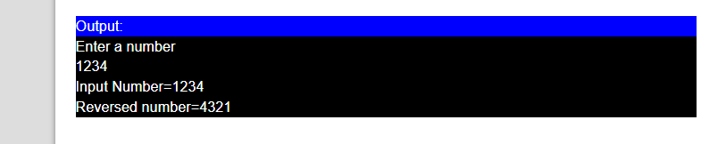*

    //54 Write a Program to print factorial using goto statemnt

#include <stdio.h>

int main()

{

long int a,n=1;

printf("\nEnter the number :");

scanf("%ld",&a);

start:

n=n*a;

a--;

if(a>0)

{

goto start;

}

printf("\nThe Total value is :%ld",n);

return 0;

}

Output

Enter the number:5

The Total value is:120

//55 Write a Program to count digits of number using goto

#include <stdio.h>

int main() {

long long n;

int count = 0;

printf("Enter an integer: ");

scanf("%lld", &n);

// iterate at least once, then until n becomes 0

// remove last digit from n in each iteration

// increase count by 1 in each iteration

Label:

n /= 10;

++count;

If(n>0)

goto label;

printf("Number of digits: %d", count);

}Output:

Enter the Number : 15

No of Digits : 2

//56 Wap to find sum of digits using goto

 #include <stdio.h>

int main() {

long long n;

int count = 0;

printf("Enter an integer: ");

scanf("%lld", &n);

// iterate at least once, then until n becomes 0

// remove last digit from n in each iteration

// increase count by 1 in each iteration

Label:

r =n%10;

sum=sum+r;

n /= 10;

If(n>0)

goto Label;

printf("Number of digits: %d", count);

}Output:

Enter the Number : 15

No of Digits : 2

//57 Write a program to check whether a number is palindrome or not

…

#include <stdio.h>

int main() {

int n, reversed = 0, remainder, original;

printf("Enter an integer: ");

scanf("%d", &n);

original = n;

// reversed integer is stored in reversed variable

label:

remainder = n % 10;

reversed = reversed * 10 + remainder;

n /= 10;

if(n>0)

goto label;

// palindrome if orignal and reversed are equal

if (original == reversed)

printf("%d is a palindrome.", original);

else

printf("%d is not a palindrome.", original);

return 0;

}

/Output

Enter an integer: 121

121 is a palindrome.

//58 Write a program to check number is Armstrong or not

#include <stdio.h>

int main() {

int num, originalNum, remainder, result = 0;

printf("Enter a three-digit integer: ");

scanf("%d", &num);

originalNum = num;

label: {

// remainder contains the last digit

remainder = originalNum % 10;

result += remainder * remainder * remainder;

// removing last digit from the orignal number

originalNum /= 10;

if(originalNum != 0)

goto label;

}

if (result == num)

printf("%d is an Armstrong number.", num);

else

printf("%d is not an Armstrong number.", num);

return 0;

}

    Output:

Enter a three-digit integer: 371

371 is an Armstrong number.

//59 Find min/max in array using goto

#include <stdio.h>

int main()

{

int a[1000],i,n,min,max;

printf("Enter size of the array : ");

scanf("%d",&n);

printf("Enter elements in array : ");

for(i=0; i<n; i++)

{

scanf("%d",&a[i]);

}

min=max=a[0];

label:

{ i=1;

if(min>a[i])

min=a[i];

if(max<a[i])

max=a[i];

i++;

}

if(i<n)

goto label;

printf("minimum of array is : %d",min);

printf("\nmaximum of array is : %d",max);

return 0;

}

OutputC

1

2

3

4

5

6

7

8

Enter size of the array: 5

Enter elements in array: 1

2

3

4

5

minimum of an array is: 1

maximum of an array is: 5

//60 Prgm: C prgrm to calculate Factorial of a Number using goto

#include <stdio.h>

int main()

{

    int n, i,a,b;

    unsigned long long fact = 1;

  printf(“Enter the starting and final range of number”);

scanf(“%d %d,&a,&b);

    printf("Enter an integer: ");

    scanf("%d", &n);

    // shows error if the user enters a negative integer

    if (n < 0)

        printf("Error! Factorial of a negative number doesn't exist.");

    else {

label:

i = 1;

            fact *= i;

++i;

        If(i <= n)

goto label;

        printf("Factorial of %d = %llu", n, fact);

    }

    return 0;

}

OUTPUT:

Enter number:5

Factorial is :120

//61Prgm to find even number in range using Goto

#include <stdio.h>

int main()

{

int i, n;

/* Input upper limit of even number from user */

printf("Print all even numbers till: ");

scanf("%d", &n);

printf("Even numbers from 1 to %d are: \n", n);

for(i=1; i<=n; i++)

{

/* Check even condition before printing */

if(i%2 == 0)

{

printf("%d\n", i);

}

}

return 0;

}

Even numbers between 1 to 100

2 4 6 8 10 12 14 16 18 20 22 24 26 28 30 32 34 36 38 40 42 44 46 48 50 52 54 56 58 60 62 64 66 68 70 72 74 76 78 80 82 84 86 88 90 92 94 96 98 100

//63 Even numbers in range using while loop

#include <stdio.h>

int main() {

int counter;

printf("Odd numbers between 1 to 100\n");

/*

* Initialize counter with first odd number 1, and increment

* it by 2 in every iteration.

*/

counter = 1;

while (counter <= 100) {

printf("%d ", counter);

/* Add 2 to current even number

to get next odd number */

counter = counter + 1;

}

return 0;

}

Output

Even numbers between 1 to 100

2 4 6 8 10 12 14 16 18 20 22 24 26 28 30 32 34 36 38 40 42 44 46 48 50 52 54 56 58 60 62 64 66 68 70 72 74 76 78 80 82 84 86 88 90 92 94 96 98 100

//64 Write a prgm using do-while loop

#include <stdio.h>

int main() {

int counter;

printf("Even numbers between 1 to 100\n");

/*

* Initialize counter with first odd number 1, and increment

* it by 2 in every iteration.

*/

counter = 1;

do {

printf("%d ", counter);

/* Add 2 to current odd number

to get next odd number */

counter = counter + 1;

} while (counter <= 100);

return 0;

}

Output

Even numbers between 1 to 100

0 2 6 8 11 13 15 17 19 21 23 25 27 29 31 33 35 37 39 41 43 45 47 49 51 53 55 57 59 60 62 64 66 68

//65 Prgm to find even number in range using Goto

#include <stdio.h>

int main() {

int counter;

printf("Even numbers between 1 to 100\n");

counter = 1;

label:

counter++;

/* Odd numbers are not divisible by 2. When an Odd

number is divided by 2, it leaves 1 as remainder */

if(counter%2 == 1) {

/* counter is even, print it */

printf("%d ", counter);

if(counter <= 100)

goto label:

return 0;

}

Odd numbers between 1 to 100

1 3 5 7 9 11 13 15 17 19 21 23 25 27 29 31 33 35 37 39 41 43 45 47 49 51 53 55 57 59 61 63 65 67 69 71 73 75 77 79 81 83 85 87 89 91 93 95 97 99

//66 odd number in range using for loop1

#include <stdio.h>

int main()

{

int i, n;

/* Input upper limit of even number from user */

printf("Print all even numbers till: ");

scanf("%d", &n);

printf("Even numbers from 1 to %d are: \n", n);

for(i=1; i<=n; i++)

{

/* Check even condition before printing */

if(i%2 == 0)

{

printf("%d\n", i);

}

}

return 0;

}

1 3 5 7 9 11 13 15 17 19 21 23 25 27 29 31 33 35 37 39 41 43 45 47 49 51 53 55 57 59 61 63 65 67 69 71 73 75 77 79 81 83 85 87 89 91 93 95 97 99

 //67 Odd number in range using for loop2

#include <stdio.h>

int main()

{

int i, n;

/* Input upper limit of even number from user */

printf("Print all even numbers till: ");

scanf("%d", &n);

printf("Even numbers from 1 to %d are: \n", n);

for(i=1; i<=n;)

{

/* Check even condition before printing */

if(i%2 == 0)

{

printf("%d\n", i);

}

i++;

}

return 0;

}

1 3 5 7 9 11 13 15 17 19 21 23 25 27 29 31 33 35 37 39 41 43 45 47 49 51 53 55 57 59 61 63 65 67 69 71 73 75 77 79 81 83 85 87 89 91 93 95 97 99

//68 odd numbers in range using while loop

#include <stdio.h>

int main() {

int counter;

printf("Odd numbers between 1 to 100\n");

/*

* Initialize counter with first odd number 1, and increment

* it by 2 in every iteration.

*/

counter = 1;

while (counter <= 100) {

printf("%d ", counter);

/* Add 2 to current odd number

to get next odd number */

counter = counter + 2;

}

return 0;

}

Output

Odd numbers between 1 to 100

1 3 5 7 9 11 13 15 17 19 21 23 25 27 29 31 33 35 37 39 41 43 45 47 49 51 53 55 57 59 61 63 65 67 69

//69 Write a prgm to find odd number in range using do-while loop

#include <stdio.h>

int main() {

int counter;

printf("Even numbers between 1 to 100\n");

/*

* Initialize counter with first odd number 1, and increment

* it by 2 in every iteration.

*/

counter = 1;

do {

printf("%d ", counter);

/* Add 2 to current odd number

to get next odd number */

counter = counter + 2;

} while (counter <= 100);

return 0;

}

Output

Odd numbers between 1 to 100

1 3 5 7 9 11 13 15 17 19 21 23 25 27 29 31 33 35 37 39 41 43 45 47 49 51 53 55 57 59 61 63 65 67 69 71 73 75 77 79 81 83 85 87 89 91 93 95 97 99

//70 Prgm to find even number in range using Goto

#include <stdio.h>

int main() {

int counter;

printf("Even numbers between 1 to 100\n");

counter = 1;

label:

counter++;

/* Odd numbers are not divisible by 2. When an Odd

number is divided by 2, it leaves 1 as remainder */

if(counter%2 == 1) {

/* counter is odd, print it */

printf("%d ", counter);

if(counter <= 100)

goto label:

return 0;

}

Odd numbers between 1 to 100

1 3 5 7 9 11 13 15 17 19 21 23 25 27 29 31 33 35 37 39 41 43 45 47 49 51 53 55 57 59 61 63 65 67 69 71 73 75 77 79 81 83 85 87 89 91 93 95 97 99

///71WAP to Check that given number is palindrome or not (goto)

#include <stdio.h>

int main() {

  int n, reversed = 0, remainder, original;

    printf("Enter an integer: ");

    scanf("%d", &n);

    original = n;

    // reversed integer is stored in reversed variable

    label:

{

        remainder = n % 10;

        reversed = reversed * 10 + remainder;

        n /= 10;

    }

If (n != 0)

goto label;

    // palindrome if orignal and reversed are equal

    if (original == reversed)

        printf("%d is a palindrome.", original);

    else

        printf("%d is not a palindrome.", original);

    return 0;

}

Enter an integer: 1001

1001 is a palindrome.

//80. WAP to find Prime Numbers in range.(goto)

#include <stdio.h>

int main()

{

int i, a = 1, count;

label:

{

count = 0;

i = 2;

label:

{

if(a%i == 0)

{

count++;

break;

}

i++;

}

if(i <= a/2)

goto label;

if(count == 0 && a != 1 )

{

printf(" %d ", a);

}

a++;

}

if(a <= 100)

goto label;

return 0;

}

Output:

2 3 5 7 11 13 17 19 23 29 31 37 41 43 47 53 59 61 67 71 73 79 83 89 97

//81 WAP to find Prime Numbers in range using while loop

#include <stdio.h>

int main()

{

int i, a = 1, count;

while(a <= 100)

{

count = 0;

i = 2;

while(i <= a/2)

{

if(a%i == 0)

{

count++;

break;

}

i++;

}

if(count == 0 && a != 1 )

{

printf(" %d ", a);

}

a++;

}

}

return 0;

}

Output:

2 3 5 7 11 13 17 19 23 29 31 37 41 43 47 53 59 61 67 71 73 79 83 89 97

//83 WAP to find Prime Numbers in range using for loop1

#include <stdio.h>

int main()

{

int i, a = 1, count;

for(a=1;a <= 100; a++)

{

count = 0;

i = 2;

while(i <= a/2)

{

if(a%i == 0)

{

count++;

break;

}

i++;

}

if(count == 0 && a != 1 )

{

printf(" %d ", a);

}

}

}

return 0;

}

Output:

2 3 5 7 11 13 17 19 23 29 31 37 41 43 47 53 59 61 67 71 73 79 83 89 97

//84 WAP to find Prime Numbers in range using for loop2

#include <stdio.h>

int main()

{

int i, a = 1, count;

for(a=1;a <= 100;)

{

count = 0;

i = 2;

while(i <= a/2)

{

if(a%i == 0)

{

count++;

break;

}

i++;

}

if(count == 0 && a != 1 )

{

printf(" %d ", a);

}

}

a++;

}

return 0;

}

Output:

2 3 5 7 11 13 17 19 23 29 31 37 41 43 47 53 59 61 67 71 73 79 83 89 97

//85  WAP to Check that given number is Armstrong Number or not (goto).

.#include<stdio.h>

 int main()

{

int n,r,sum=0,temp;

printf("enter the number=");

scanf("%d",&n);

temp=n;

label:

{

r=n%10;

sum=sum+(r*r*r);

n=n/10;

}

if(temp==sum)

printf("armstrong  number ");

else

printf("not armstrong number");

return 0;

 }

if(n>0)

goto label;

OUTPUT:

Input  a number: 153

153 is an Armstrong number

**03/02/2022 Array 11 Programs using C only**

**//1 Write a program to input and print elemnts of Array**

**//2 write a Program to input numbers and print their sum and their avg.**

**//3Elemnt to find position of integer**

**//4 C program to accept N numbers and arrange them in an ascending order**

**//5 C program to accept N numbers and arrange them in an descending order**

**// 7 to print even numbers in a given array**

**//1 Write a program to input and print elemnts of Array**

#include<stdio.h>

int main()

{

int i,n;

printf("\n Enter The Total Numbers:");

scanf("%d",&n);

int arr[n];

printf("\n Start Entering The Number:");

for(i=0;i<n;i++)

{

scanf("%d",&arr[i]);

}

printf("\nnumbers entered are\n");

for(i=0;i<n;i++)

{

printf("%d\n",arr[i]);

}

return 0;

}

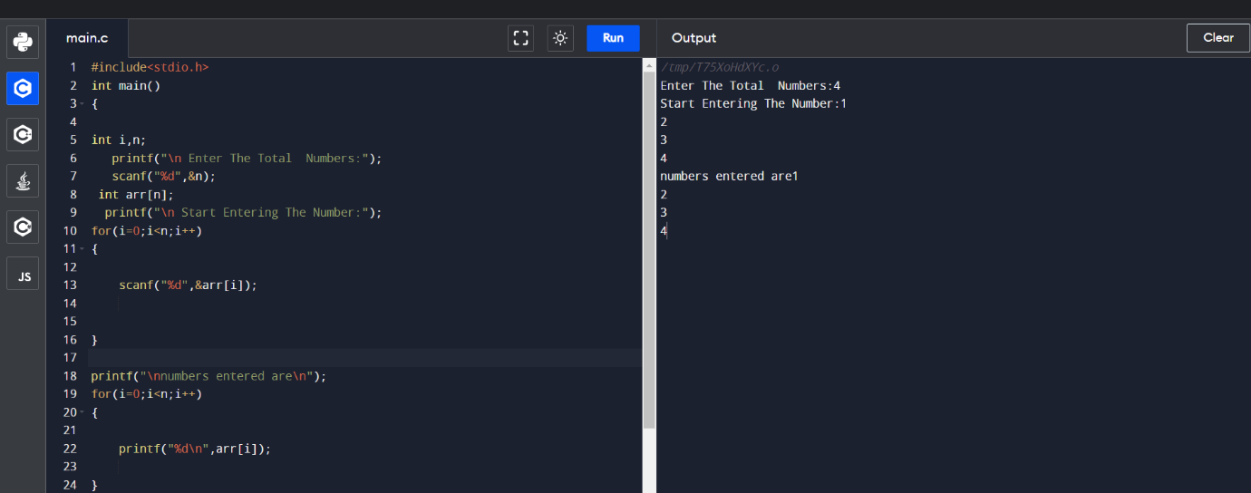

**//2 write a Program to input numbers and print their sum and their avg.**

#include<stdio.h>

int main()

{

int i,n,sum=0;

printf("\n Enter The Total Numbers:");

scanf("%d",&n);

int arr[n];

printf("\n Start Entering The Number:");

for(i=0;i<n;i++)

{

scanf("%d",&arr[i]);

sum=sum+arr[i];

}

printf("\nnumbers entered are\n");

for(i=0;i<n;i++)

{

printf("%d\n",arr[i]);

}

printf("\nSum of enterd no %d\n",sum);

printf("\nAvg of enterd no %d\n",sum/n);

return 0;

}

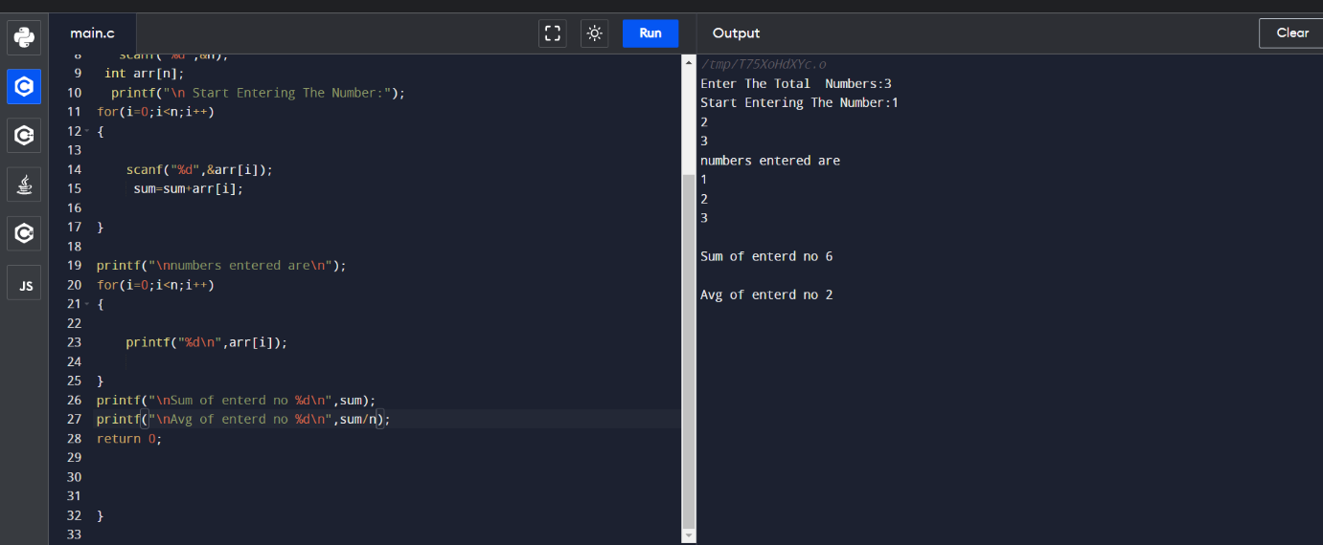

**//3Elemnt to find position of integer**

#include<stdio.h>

int main()

{

sort

}

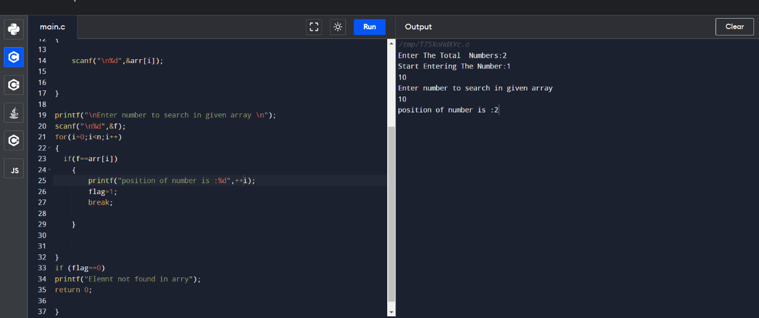

**4 C program to accept N numbers and arrange them in an ascending order**

#include <stdio.h>

void main()

{

int i, j, a, n, number[30];

printf("Enter the value of N \n");

scanf("%d", &n);

printf("Enter the numbers \n");

for (i = 0; i < n; ++i)

scanf("%d", &number[i]);

for (i = 0; i < n; ++i)

{

for (j = i + 1; j < n; ++j)

{

if (number[i] > number[j])

{

a = number[i];

number[i] = number[j];

number[j] = a;

}

}

}

printf("The numbers arranged in ascending order are given below \n");

for (i = 0; i < n; ++i)

printf("%d\n", number[i]);

}

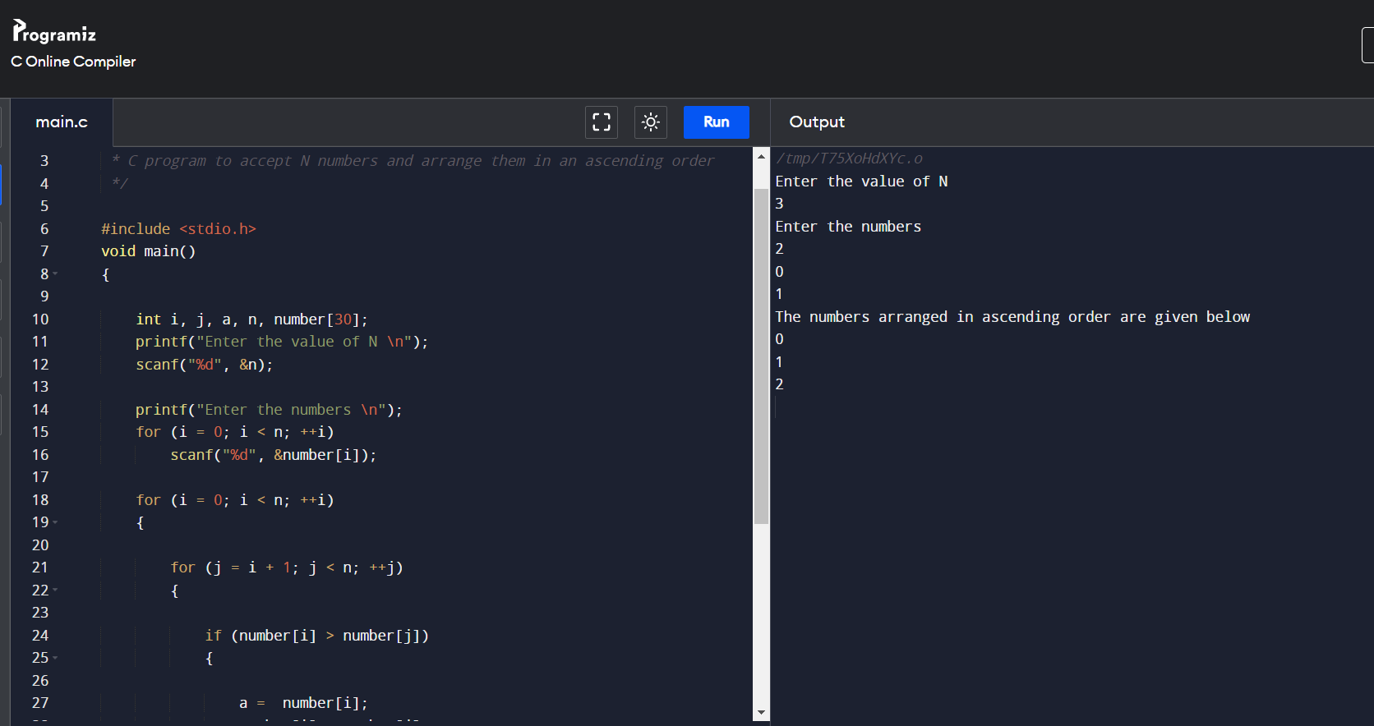

**5 C program to accept N numbers and arrange them in an decending order**

/*

*

*/

#include <stdio.h>

void main()

{

int i, j, a, n, number[30];

printf("Enter the value of N \n");

scanf("%d", &n);

printf("Enter the numbers \n");

for (i = 0; i < n; ++i)

scanf("%d", &number[i]);

for (i = 0; i < n; ++i)

{

for (j = i + 1; j < n; ++j)

{

if (number[i] < number[j])

{

a = number[i];

number[i] = number[j];

number[j] = a;

}

}

}

printf("The numbers arranged in descending order are given below \n");

for (i = 0; i < n; ++i)

printf("%d\n", number[i]);

}

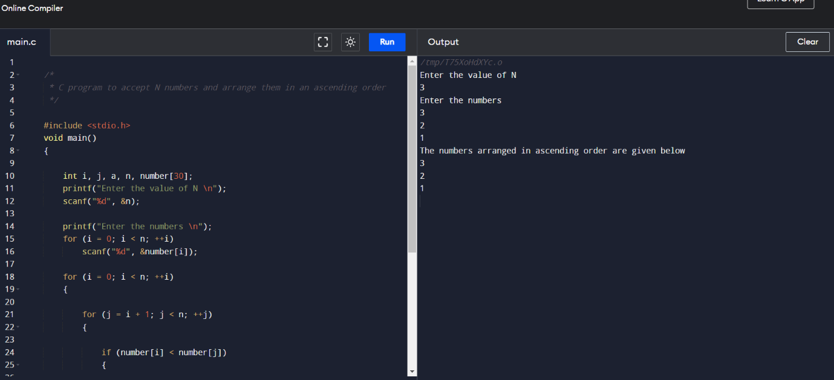

//6 odd count

/*

* C program to accept N numbers and arrange them in an ascending order

*/

#include <stdio.h>

void main()

{

int i, count, n, number[30];

printf("Enter the value of N \n");

scanf("%d", &n);

printf("Enter the numbers \n");

for (i = 0; i < n; ++i)

scanf("%d", &number[i]);

for (i = 0; i < n; ++i)

{

if (number[i]%2)

{

count++;

}

}

printf("The odd numbers count is \n");

printf("%d\n", count);

}

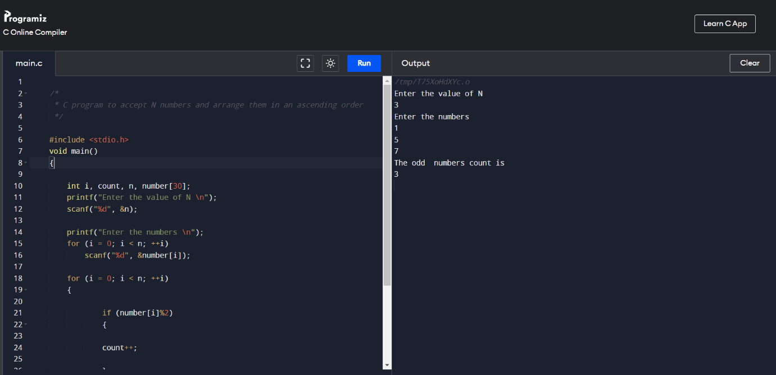

**// 7 to print even numbers in a given array**

/*

*/

#include <stdio.h>

void main()

{

int i, count, n, number[30];

printf("Enter the value of N \n");

scanf("%d", &n);

printf("Enter the numbers \n");

for (i = 0; i < n; ++i)

scanf("%d", &number[i]);

for (i = 0; i < n; ++i)

{

if (number[i]%2)

{

continue;

}

else

count++;

}

printf("The odd numbers count is \n");

printf("%d\n", count);

}

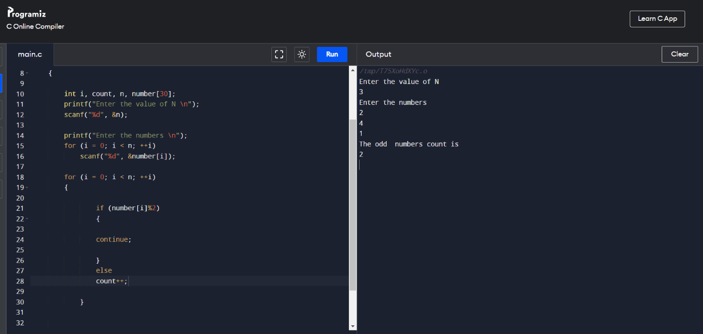

**//8* C program to count number of digits in every element of array**

#include <stdio.h>

void main()

{

int i, n;

printf("Enter the value of N \n");

scanf("%d", &n);

int number[n],countt[n];

printf("Enter the numbers \n");

for (i = 0; i < n; ++i)

scanf("%d", &number[i]);

for (i = 0; i < n; i++)

{

int remainder,res=0,j;

int count=0;

for(j=0;number[i]!='\0';j++)

{

remainder =number[i]%10;

count++;

number[i]=number[i]/10;

}

countt[i]=count;

}

for (i = 0; i < n; ++i)

printf("\nDigits of number at index %d is : %d ",i,countt[i]);

}

**// 9Addition of digits**

/*

* C program to accept N numbers and arrange them in an ascending order

*/

#include <stdio.h>

void main()

{

int i, n,sum;

printf("Enter the value of N \n");

scanf("%d", &n);

int number[n],countt[n];

printf("Enter the numbers \n");

for (i = 0; i < n; ++i)

scanf("%d", &number[i]);

for (i = 0; i < n; i++)

{

int remainder,res=0,j;

int count=0;

for(j=0;number[i]!='\0';j++)

{

remainder =number[i]%10;

sum=sum+remainder;

number[i]=number[i]/10;

}

countt[i]=sum;

sum=0;

}

for (i = 0; i < n; ++i)

printf("\nsum of Digits of number at index %d is : %d ",i,countt[i]);

}

..

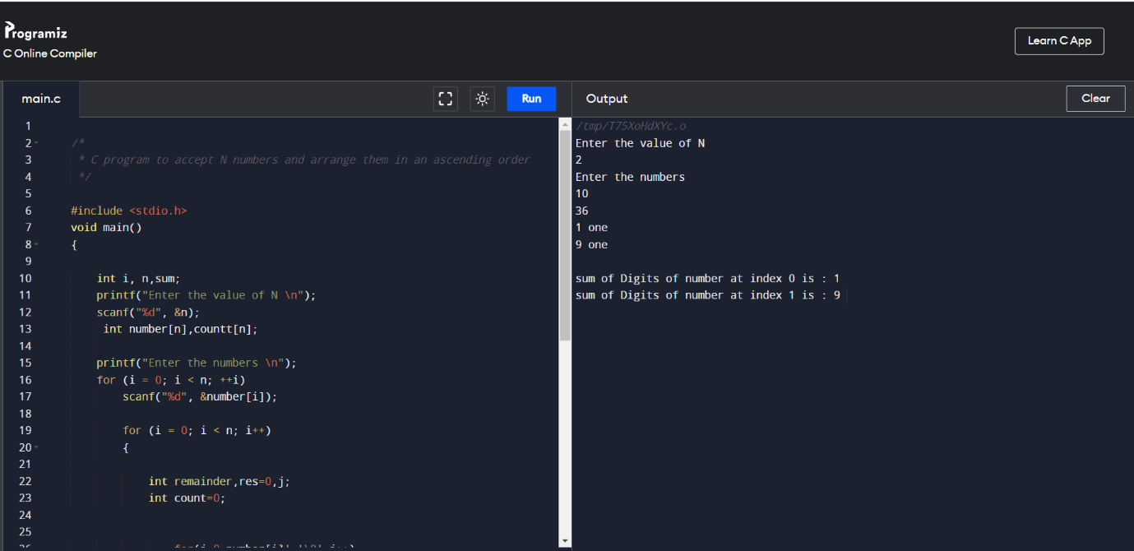

**//10 function to check number is prime or not**

#include <stdio.h>

//function to check number is prime or not

//function will return 1 if number is prime

int isPrime(int num)

{

int i; //loop counter

//it will be 1 when number is not prime

int flag=0;

//loop to check number is prime or not

//we will check, if number is divisible

//by any number from 2 to num/2, then it

//will not be prime

for(i=2; i<num/2; i++)

{

if(num%i ==0)

{

flag =1;

break;

}

}

//flag is 1, if number is not prime

if(flag==1)

return 0;

else

return 1;

}

int main()

{

int loop; //loop counter

//declaring array with prime and not prime numbers

int arr[]={100, 200, 31, 13, 97, 10, 20, 11};

//calculate length of the array

int len = sizeof(arr)/sizeof(arr[0]);

//print array elements with message

//"prime" or "Not prime"

for(loop=0; loop<len; loop++)

{

printf("%3d - %s\n",arr[loop],(isPrime(arr[loop])?"Prime":"Not Prime"));

}

printf("\n");

return 0;

}

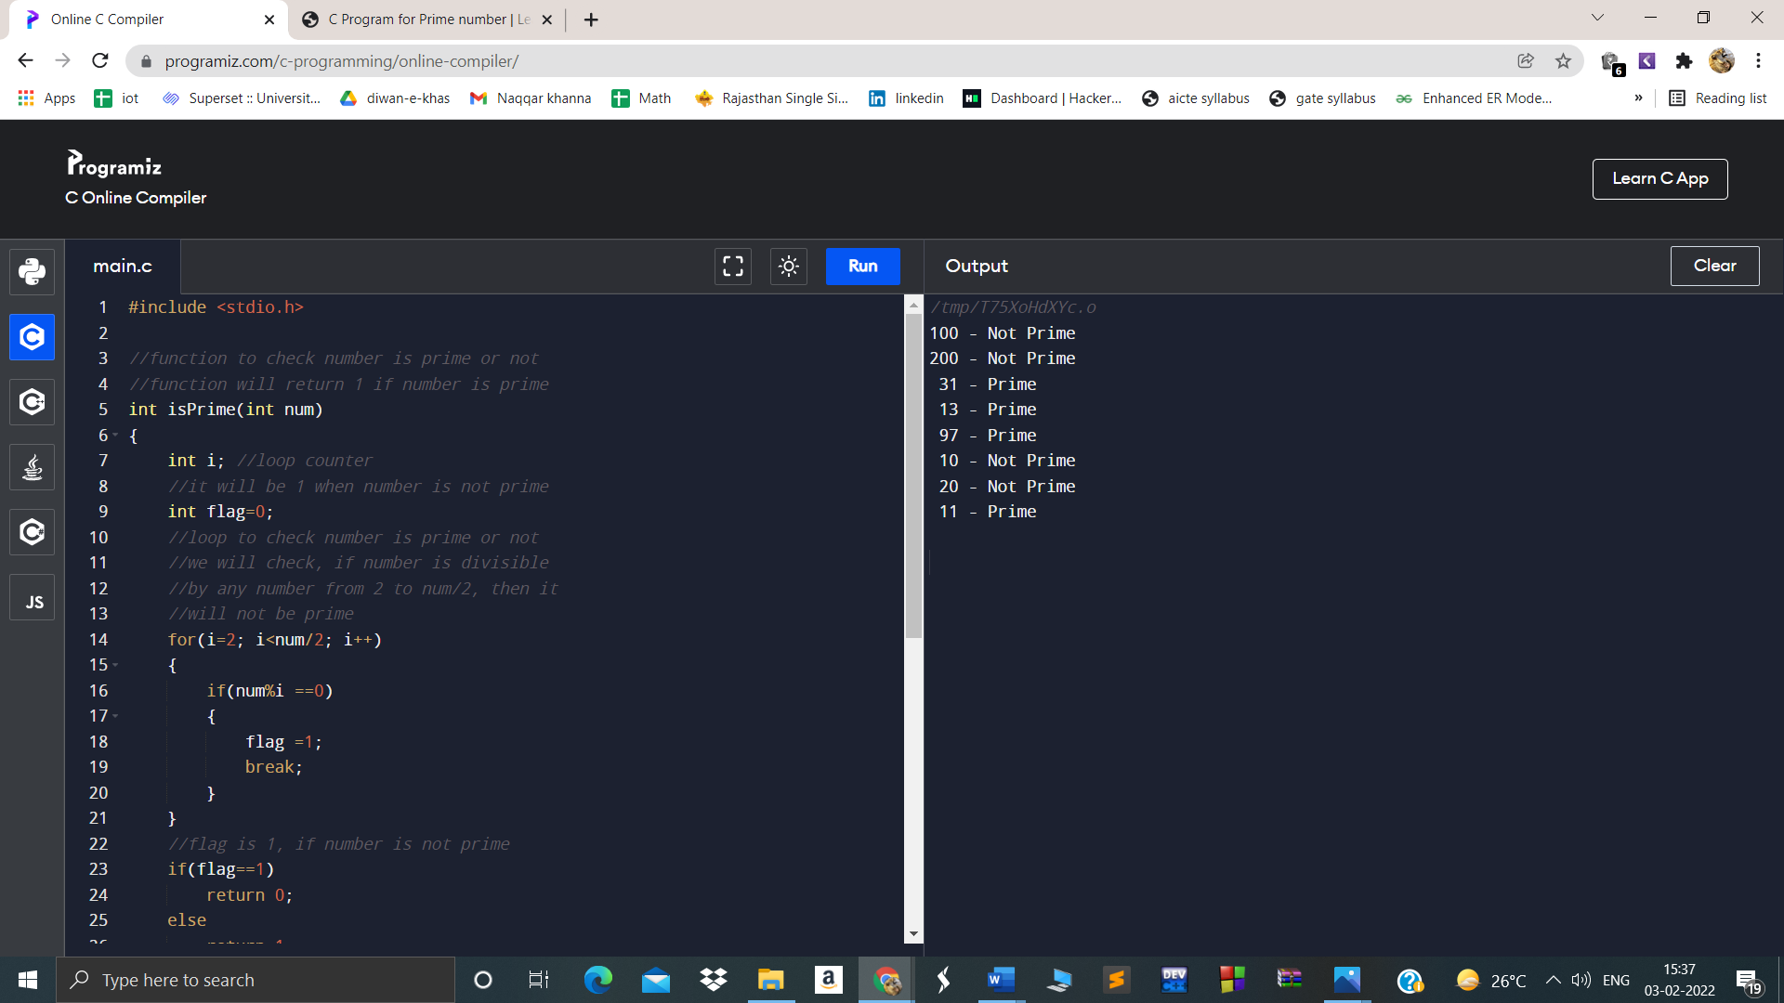

//11 prgm to check if a number is prime or not

#include <stdio.h>

//function to check number is prime or not

//function will return 1 if number is prime

void isprime(int a1)

{

int temp,flag,k;

temp=a1;

// printf("value of temp is %d\n",temp);

if(a1==1 || a1==2)

{

printf("%d is prime\t",a1);

}

for(k=2;k<a1;k++)

{

{

if( (temp%k) ==0)

{

// printf("\n %d is not prime",a1);

}

else

{

printf("%d is prime\t",a1);

}

}

break;

}

}

int main()

{

int loop; //loop counter

//declaring i with prime and not prime numbers

int arr[]={2, 200, 31, 13, 97, 10, 20, 11};

//calculate length of the array

int len = sizeof(arr)/sizeof(arr[0]);

//print array elements with message

//"prime" or "Not prime"

for(loop=0; loop<len; loop++)

{

isPrime(arr[loop];

}

printf("total count of prime is 5\n");

return 0;

}

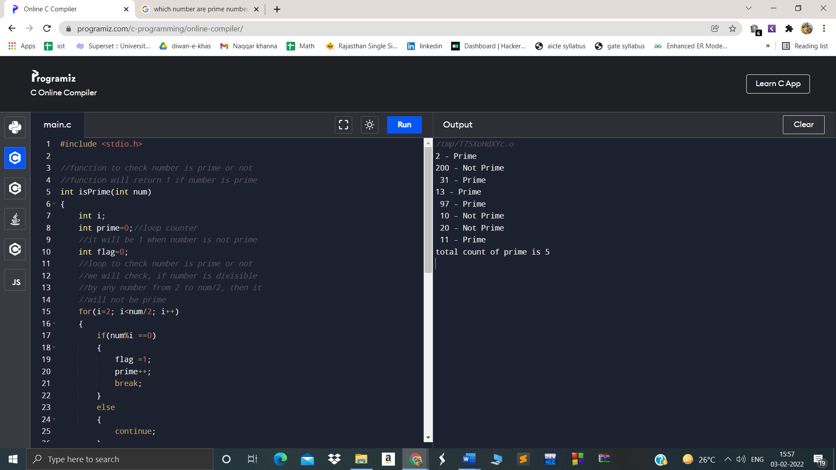

**//4/2/2022**

**2D Array ,4 Programs**

P1=Wap to print 2d Array.

P2=Wap to print prime numbers in 2d Array

P3=Wap to print Pallindrome numbers in 2d Array

P4= Wap to print Armstrong numbers in 2d Array Write a program to print 2d Array

**P1=Wap to print 2D Array**

#include <stdio.h>

int main() {

// Write C code here

int arr[3][3],i,j;

for(i=0;i<3;i++)

{

for(j=0;j<3;j++)

{

printf("\nEnter the number of position arr[%d] arr[%d] ",i,j);

scanf("%d",&arr[i][j]);

}

}

printf("\nThe Elements are \n");

for(i=0;i<3;i++)

{

for(j=0;j<3;j++)

{

printf("\t%d ",arr[i][j]);

}

printf("\n");

}

return 0;

}

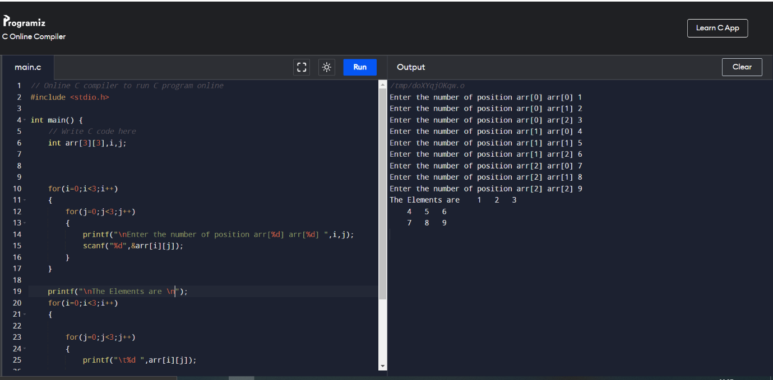

**//2Wap to print Prime numbers**

// Online C compiler to run C program online

#include <stdio.h>

void prime(int a1)

{

int temp,flag,k;

temp=a1;

// printf("value of temp is %d\n",temp);

if(a1==1 || a1==2)

{

printf("%d is prime\t",a1);

}

for(k=2;k<a1;k++)

{

{

if( (temp%k) ==0)

{

// printf("\n %d is not prime",a1);

}

else

{

printf("%d is prime\t",a1);

}

}

break;

}

}

int main() {

// Write C code here

int arr[3][3],i,j,a;

for(i=0;i<3;i++)

{

for(j=0;j<3;j++)

{

printf("\nEnter the number of position arr[%d] arr[%d] ",i,j);

scanf("%d",&arr[i][j]);

}

}

printf("\nThe Elements are \n");

for(i=0;i<3;i++)

{

for(j=0;j<3;j++)

{

a=arr[i][j];

prime(a);

}

printf("\n");

}

return 0;

}

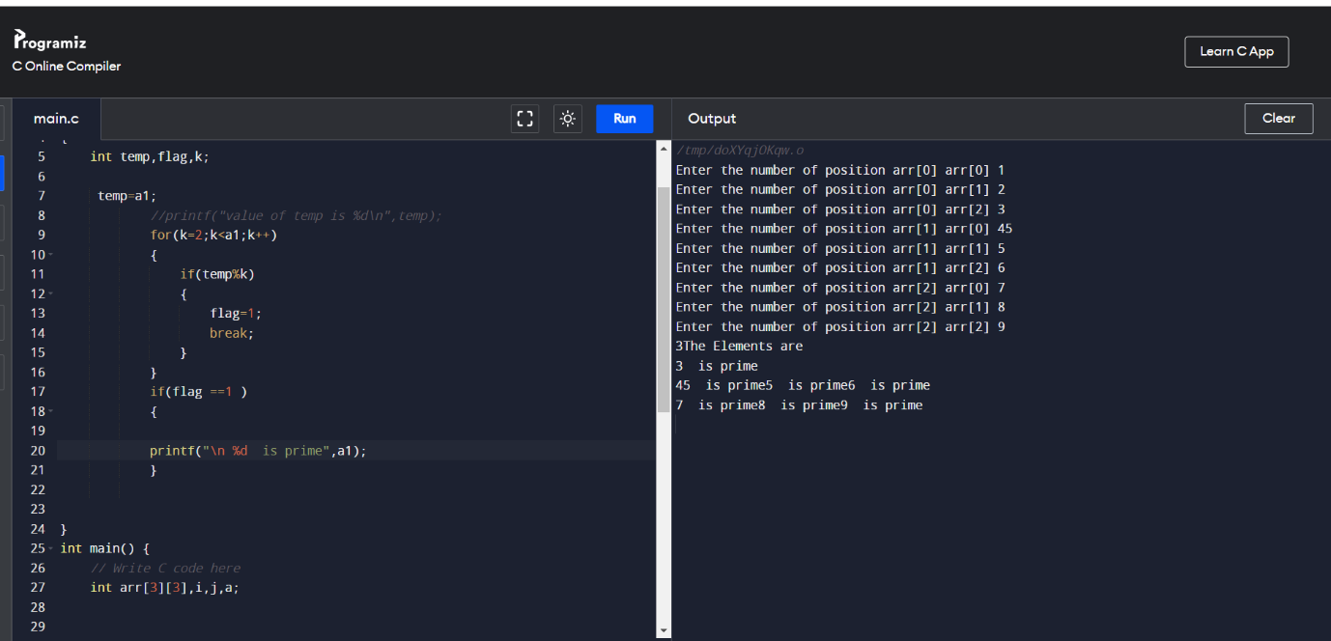

**//3** write a program to check Pallindrome numbers in 2D Array

// Online C compiler to run C program online

#include <stdio.h>

void pallindrome(int a)

{

int temp,sum=0,rem;

temp=a;

//printf("value of temp is %d\n",temp);

do

{

rem=temp%10;

sum=(sum*10) + rem;

temp=temp/10;

}while(temp!=0);

if (sum == a)

{

printf("%d is pallindrome\n",a);

}

return 0;

}

int main() {

// Write C code here

int arr[3][3],i,j,a;

for(i=0;i<3;i++)

{

for(j=0;j<3;j++)

{

printf("\nEnter the number of position arr[%d] arr[%d] ",i,j);

scanf("%d",&arr[i][j]);

}

}

printf("\nThe Elements are \n");

for(i=0;i<3;i++)

{

for(j=0;j<3;j++)

{

a=arr[i][j];

pallindrome(a);

}

printf("\n");

}

return 0;

}

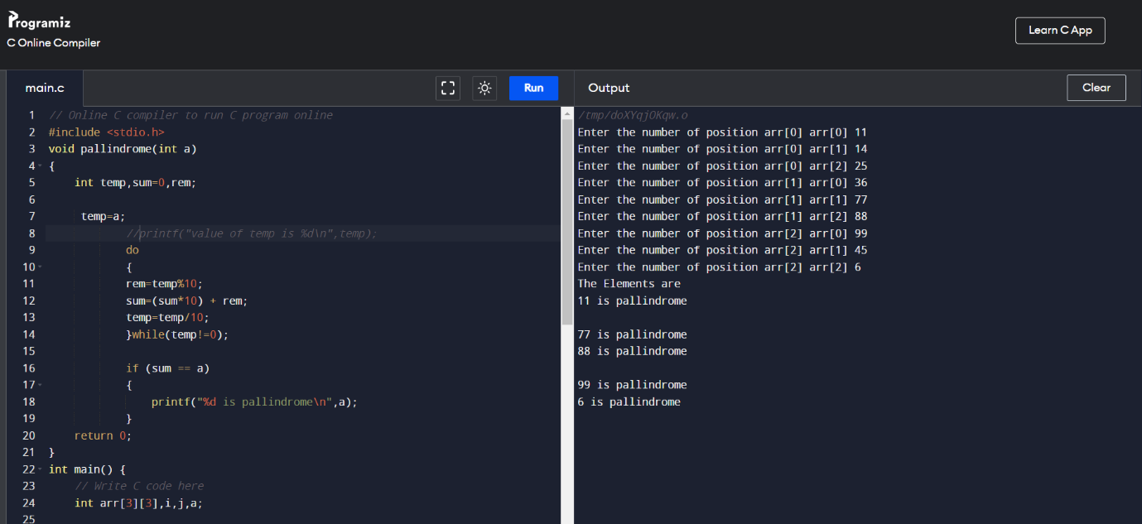

//4Write a Program to Check Armstrong number in 2D array

// Online C compiler to run C program online

#include <stdio.h>

void pallindrome(int a1)

{

int temp,sum=0,rem;

temp=a1;

while(temp!=0)

{

rem=temp%10;

sum=( sum + (rem*rem*rem) );

temp=temp/10;

}

if (sum == a1)

{

printf("%d is Armstrong\n",a1);

}

}

int main() {

// Write C code here

int arr[3][3],i,j,a;

for(i=0;i<3;i++)

{

for(j=0;j<3;j++)

{

printf("\nEnter the number of position arr[%d] arr[%d] ",i,j);

scanf("%d",&arr[i][j]);

}

}

printf("\nThe Elements of Matrix \n");

for(i=0;i<3;i++)

{

for(j=0;j<3;j++)

{

a=arr[i][j];

pallindrome(a);

}

printf("\n");

}

return 0;

}

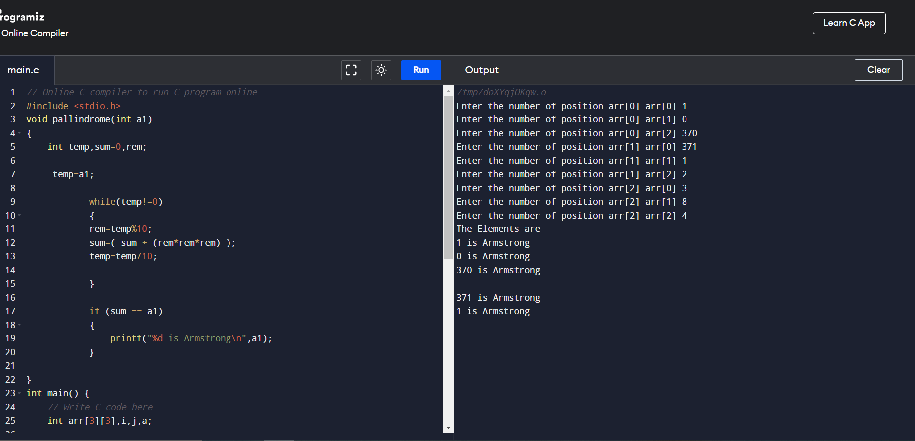

**07-02-2022 Functions**

**no argumnt no return type**

//1C prgrm to swap two variable using function

//input 1,2

//expected output=2,1

#include<stdio.h>

void swap();

int main()

{

swap();

}

void swap()

{

int a,b,c;

a=1;

b=2;

printf("Value before swap:%d %d",a,b);

c=b;

b=a;

a=c;

printf("using function no argumnt no return type Value after swap:%d %d",a,b);

return 0;

}

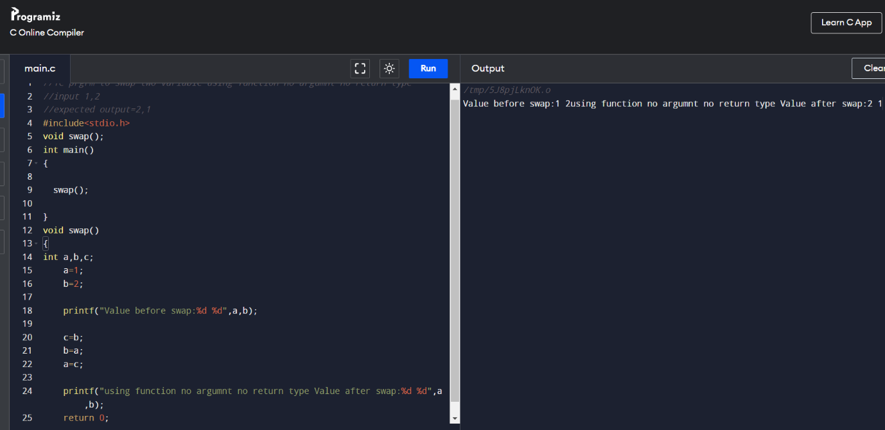

//101 To differentiate between int and float value

//prgm to print integer and float values of no

//using no argmnt ,no return type of function

//input=5.6

//output= int=5 , float=.6

#include<stdio.h>

void diff();

void main()

{

diff();

}

void diff()

{

float x;

int y;

float z;

printf("Enter the number: ");

scanf("%f",&x);

y= x;

z=x-y;

printf("Int is: %d, Float is: %f ",y,z);

}

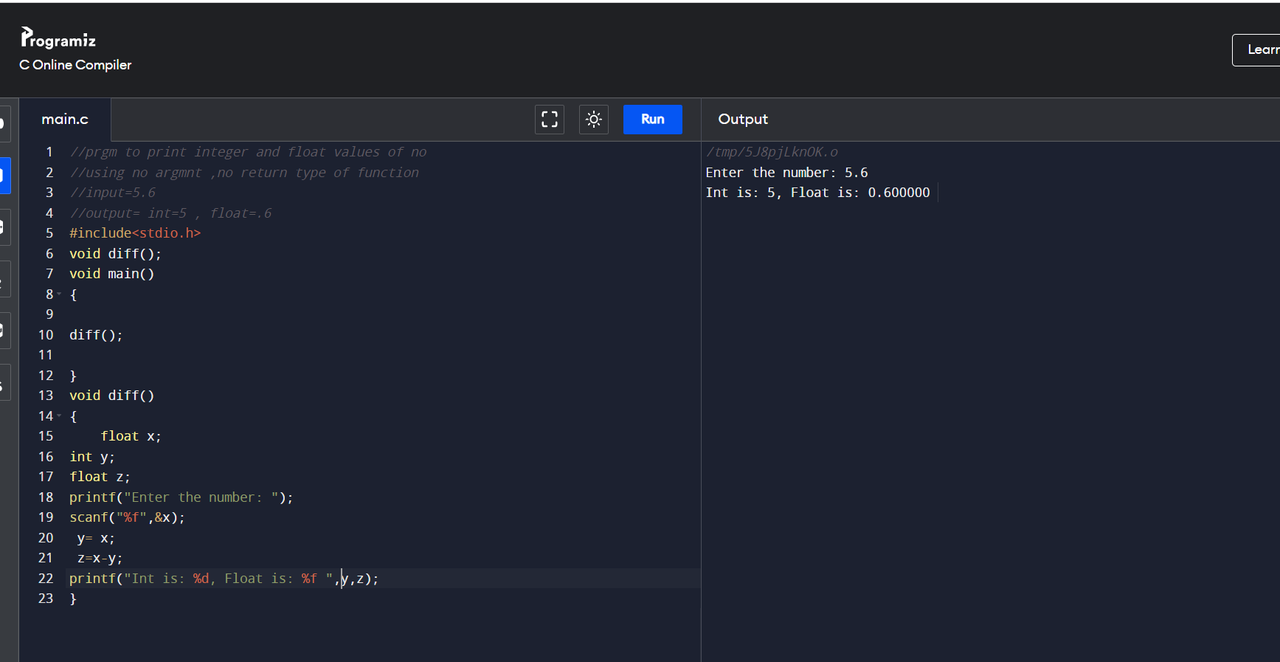

//103 Wap to find area of circle.

//using no argmnt ,no return type of function

//input=5

//output= 3.14*5*5

#include<iostream>

#include<cstdio>

void area();

int main()

{

area();

}

void area()

{

float area;

int radius;

printf("\nEnter the radius of Circle : ");

scanf("%d",&radius);

printf("\nRadiusof Circle : %d",radius);

area = 3.14 * radius * radius;

printf("\nArea of Circle : %f", area);

}

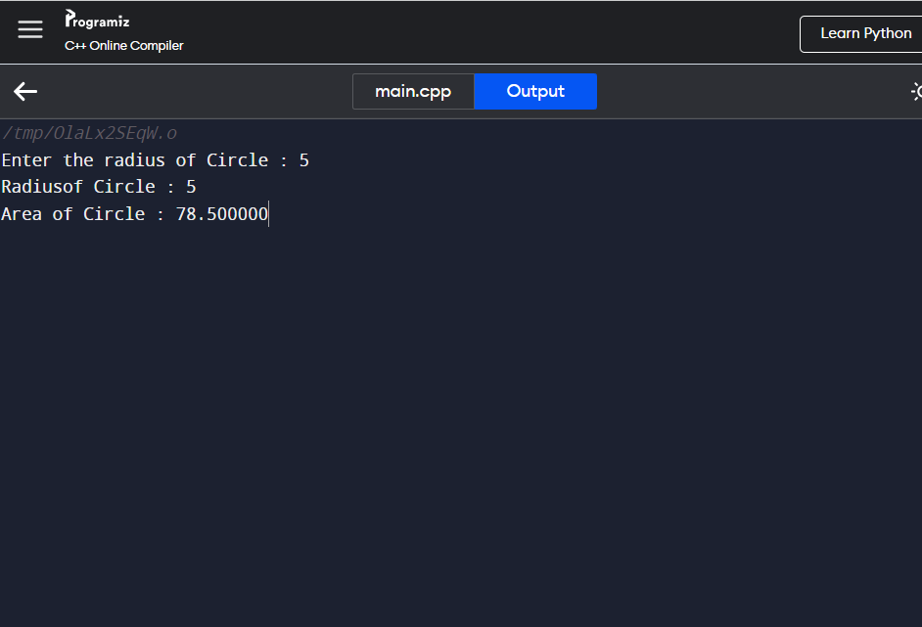

//104 Wap to find area of Rectangle

//prgm to print integer and float values of no

//using no argmnt ,no return type of function

//input=5 6

//output= 30

#include<iostream>

#include<cstdio>

void area();

int main()

{

area();

}

void area()

{

int width=5;

int height=10;

int area=width*height;

printf("Area of the rectangle=%d",area);

}

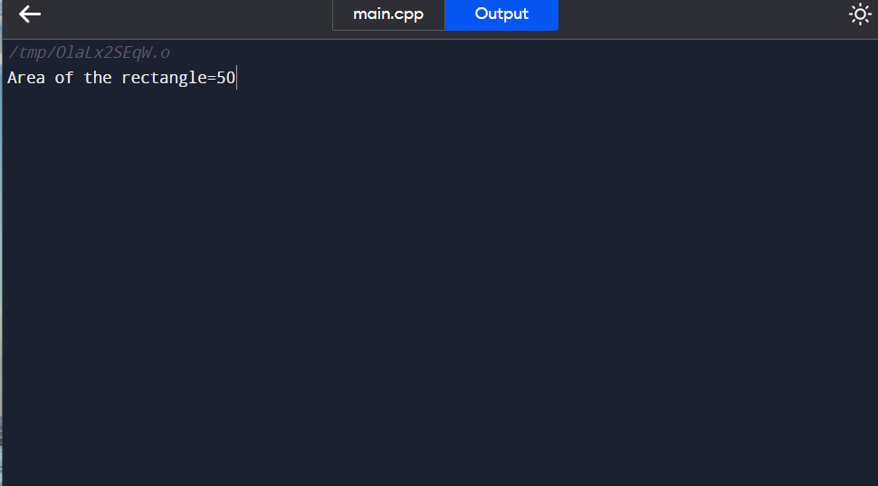

//105 Calculate simple interest

#include <stdio.h>

float value(void);

void main()

{

float f=value();

printf(" The total amount is %f:", f);

}

float value(void)

{

int year = 1, period = 5, amount = 5000, inrate = 0.12;

float sum;

sum = amount;

while (year <= period) {

sum = sum * (1 + inrate);

year = year + 1;

}

return sum;

}

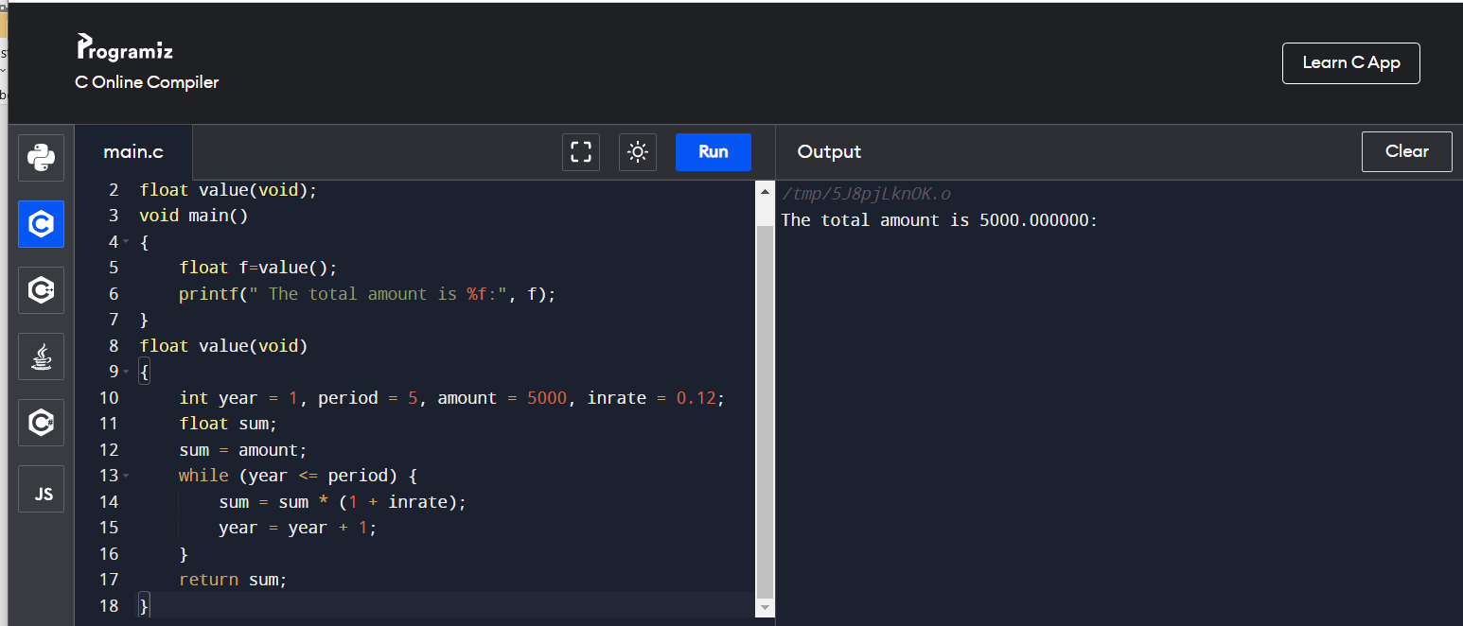

//106

Compound interest

#include <stdio.h>

float compound(void);

void main()

{

float f=compound();

printf(" The total amount is %f:", f);

}

float compound(void)

{

int amount, principal,n,sum;

int t,i;

float inrate ;

printf("enter amount,principal,no of times interest applied and time");

scanf("%d%d%d%d",&amount,&principal,&n,&t);

printf("enter interest rate");

scanf("%f",&inrate);

i=1;

while (i<=n) {

sum = (n+inrate)/n;

i++;

}

amount=principal*sum;

return sum;

}

